CDA C-CDA Content Validation of Industry Tooling Summary Document

Last Updated 2015-12-08
The eHealth Exchange Testing Workgroup

http://sequoiaproject.org/
Didi Davis, Director, Testing Programs

CDA Document Samples

- CCDA_CCD_b1_Ambulatory_v2.xml - (https://github.com/chb/sample_ccdas/blob/master/NIST%20Samples/CCDA_CCD_b1_Ambulatory_v2.xml)
- CCDA_CCD_b1_InPatient_v2.xml – (https://github.com/chb/sample_ccdas/blob/master/NIST%20Samples/CCDA_CCD_b1_InPatient_v2.xml)
- TOC_CCDA_CCD_CompGuideSample_FullXML.xml
(https://github.com/chb/sample_ccdas/blob/master/Transitions%20of%20Care%20Samples/ToC_CCDA_CCD_CompGuideSample_FullXML.xml)
- AllNegativeTestingCCDAs.zip

CDA C-CDA CCD Content Validation Tools

http://transport-testing.nist.gov/ttt/
  - CCDA_CCD_b1_Ambulatoryv2.xml
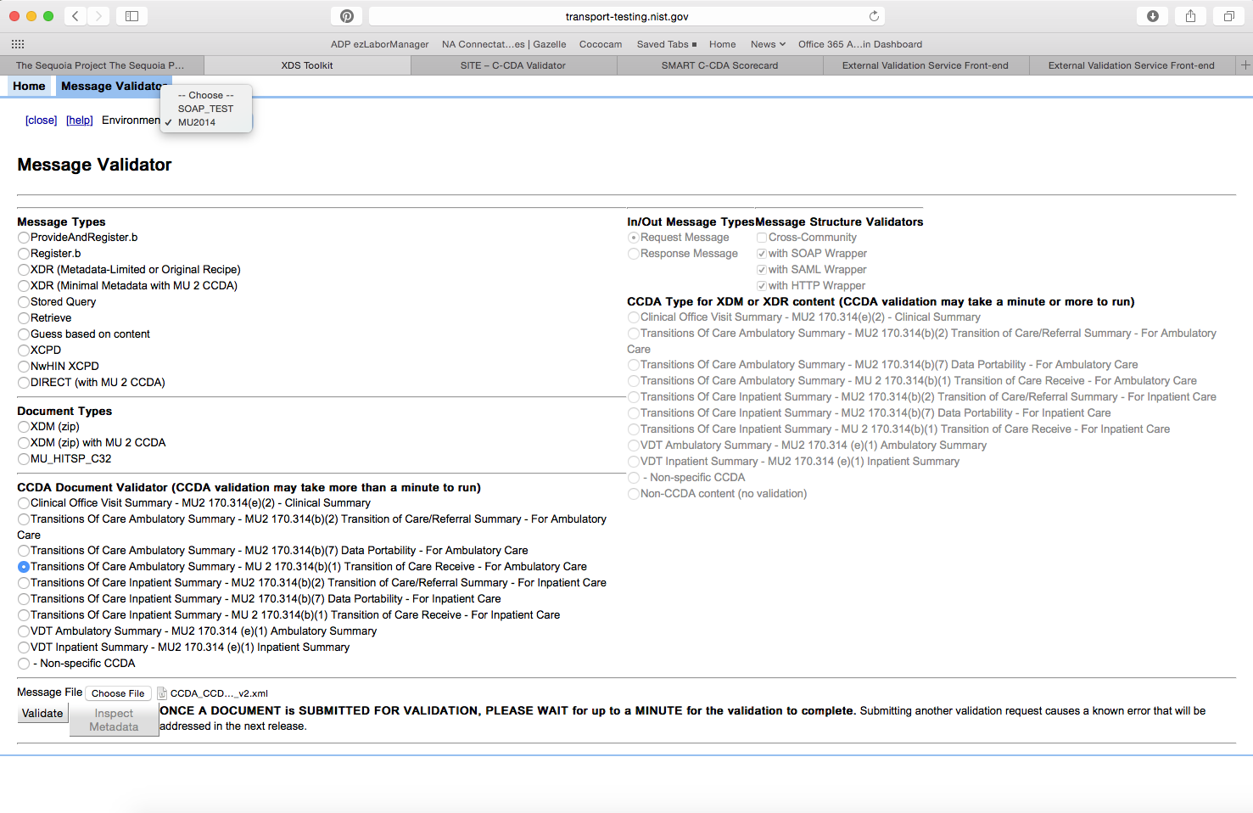
The validation was run for the above file and generated the following report: 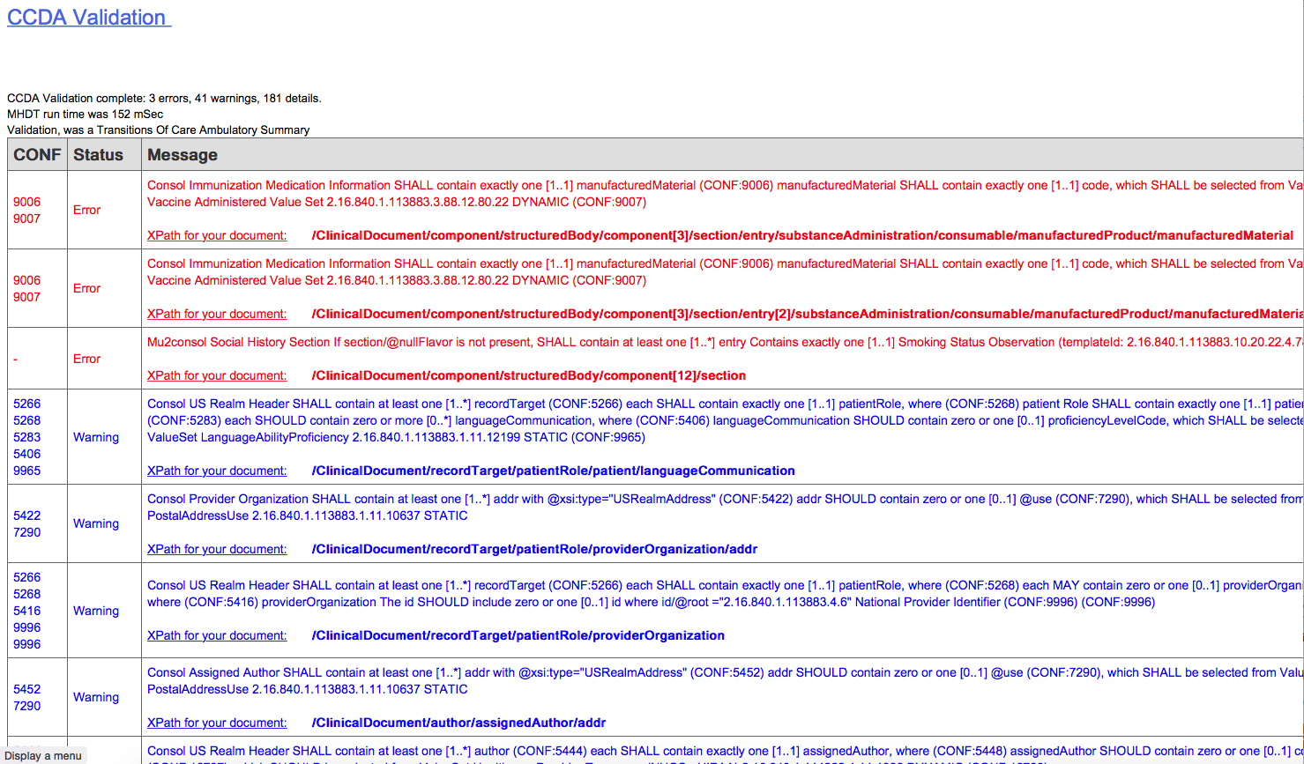

http://sitenv.org/c-cda-validator
    - CCDA_CCD_b1_Ambulatoryv2.xml
  - 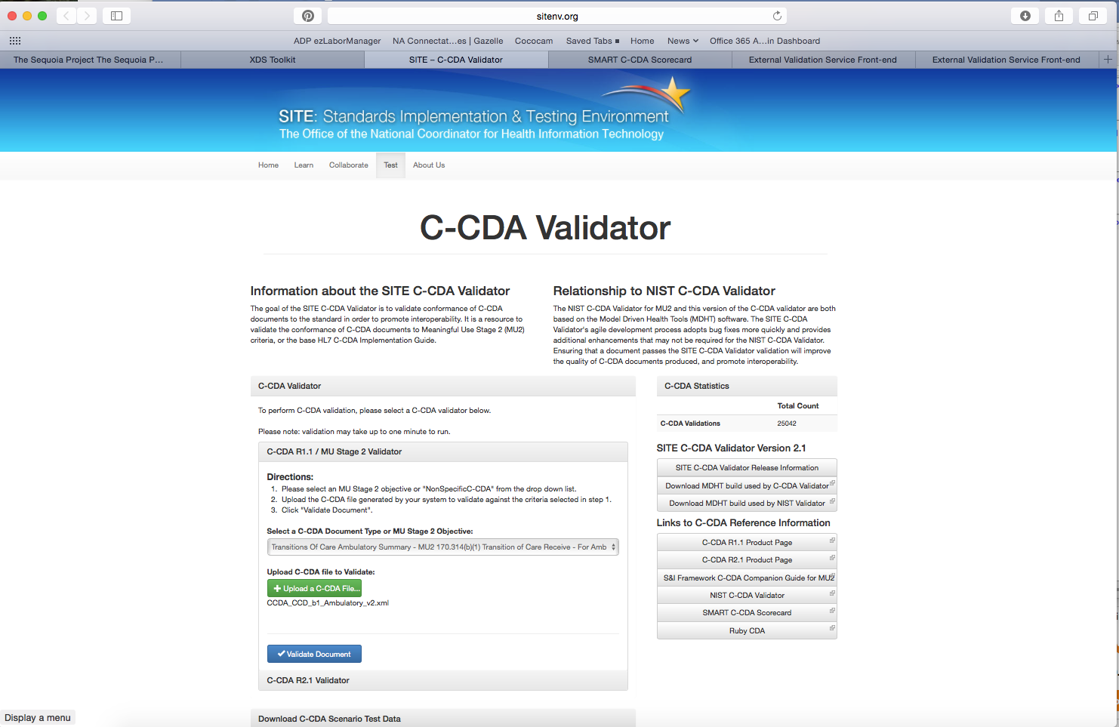
  - 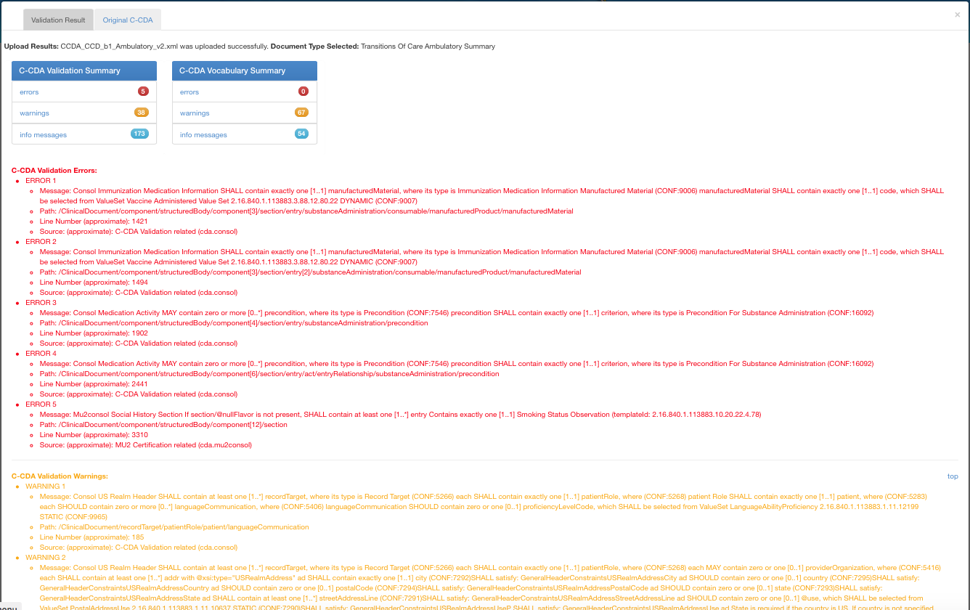
  - 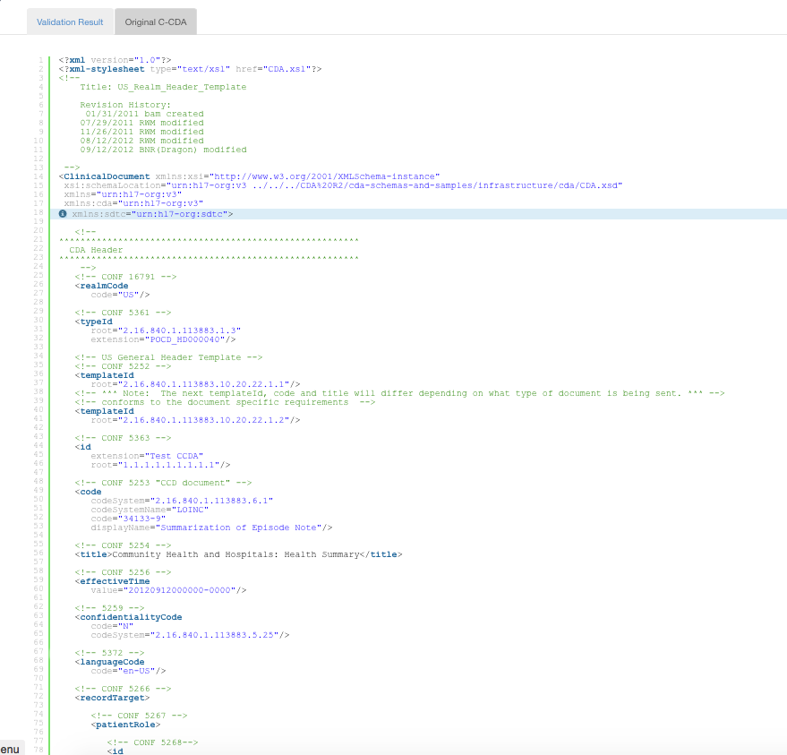

http://ccda-scorecard.smartplatforms.org/static/ccdaScorecard/#/
- CCDA_CCD_b1_Ambulatoryv2.xml
- 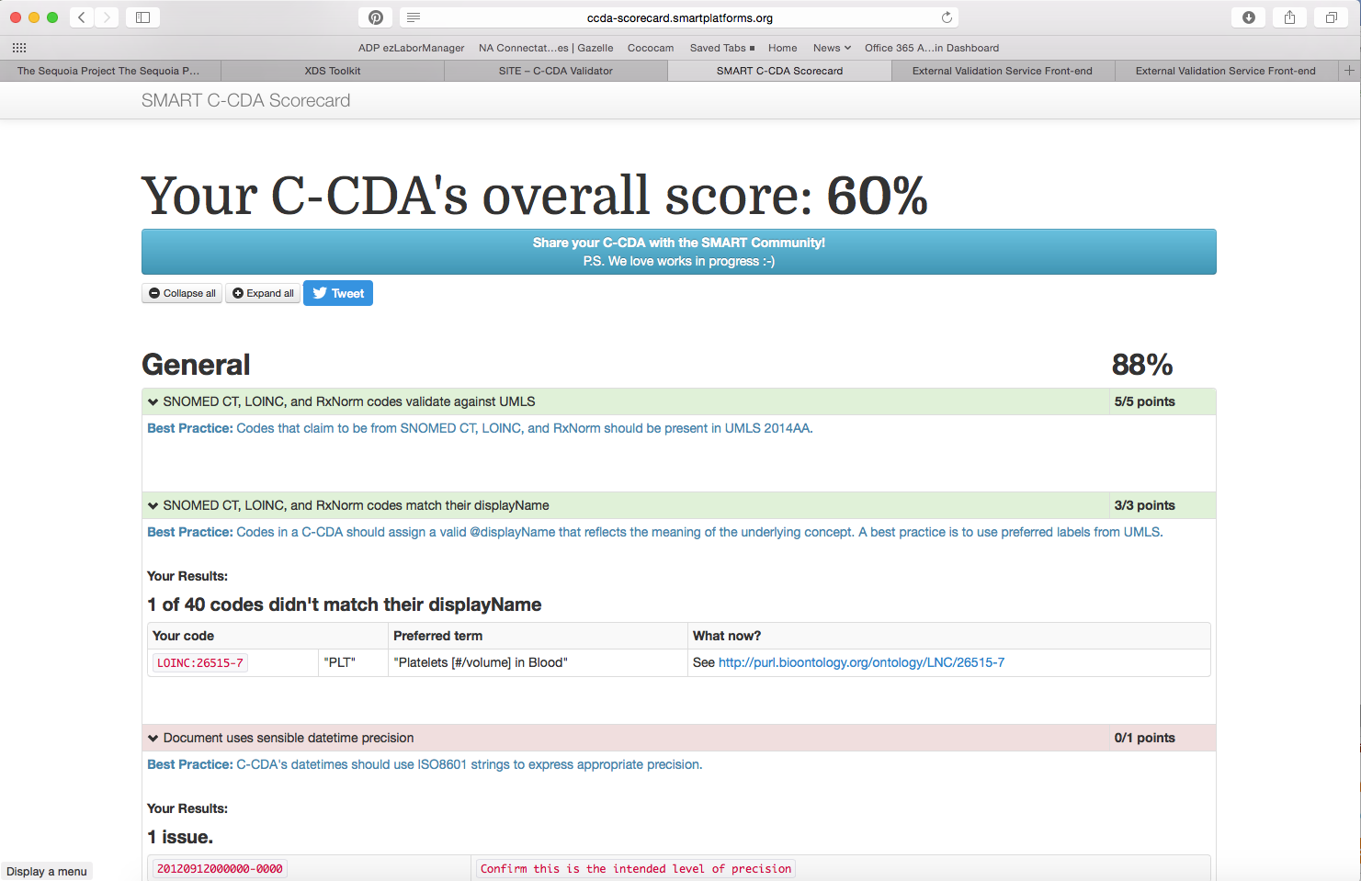

http://gazelle.ihe.net/EVSClient
  - CCDA_CCD_b1_Ambulatoryv2.xml
  - 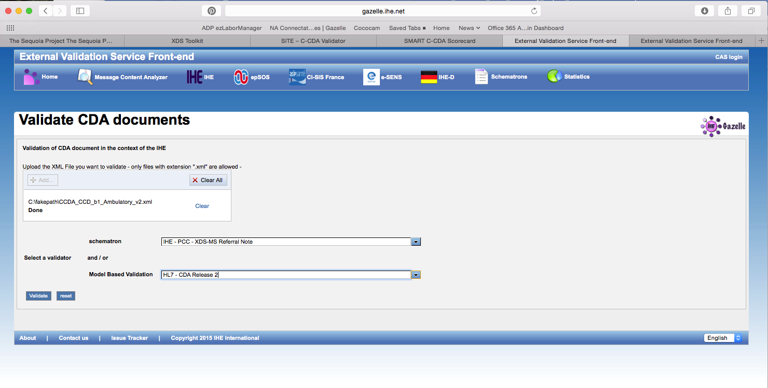
  - 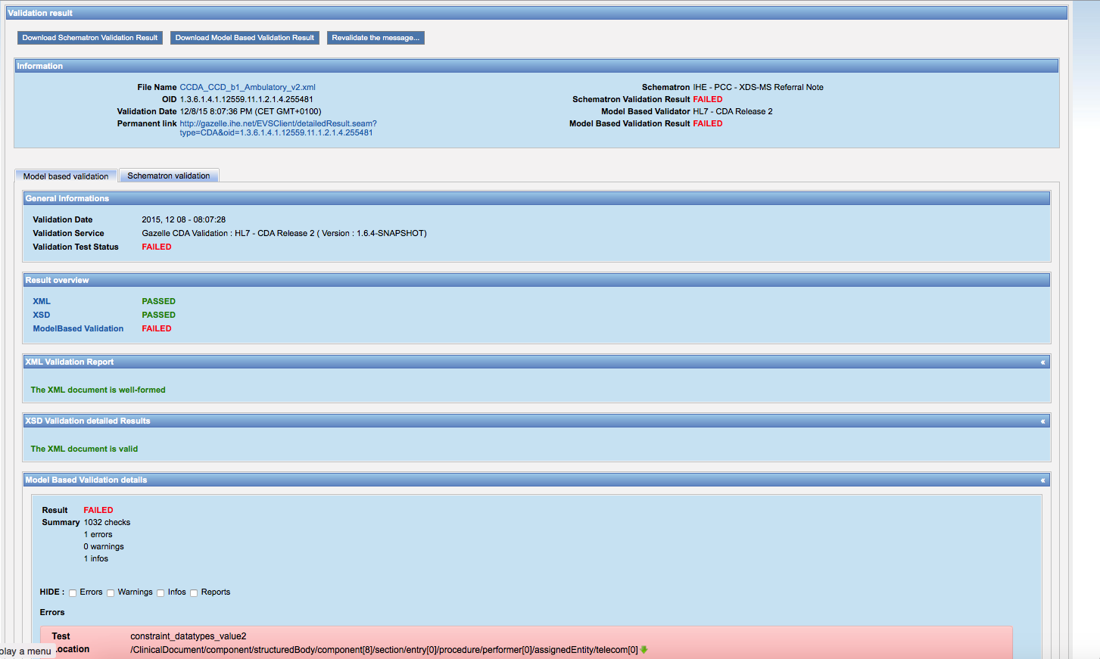
  - 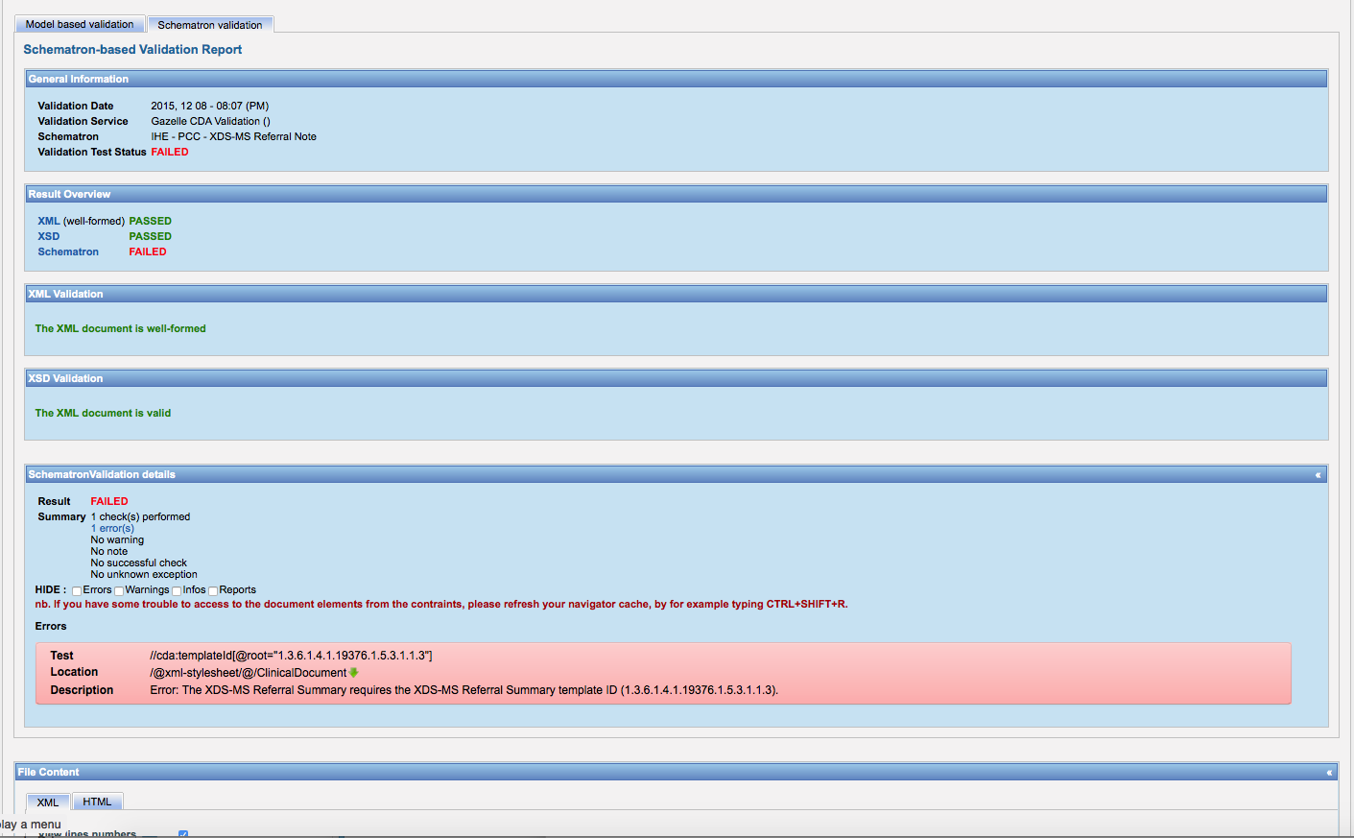
  - 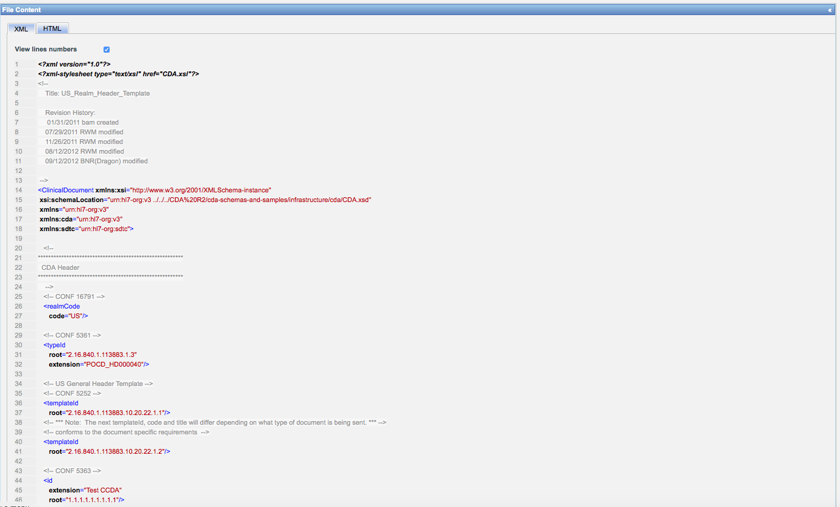
  - 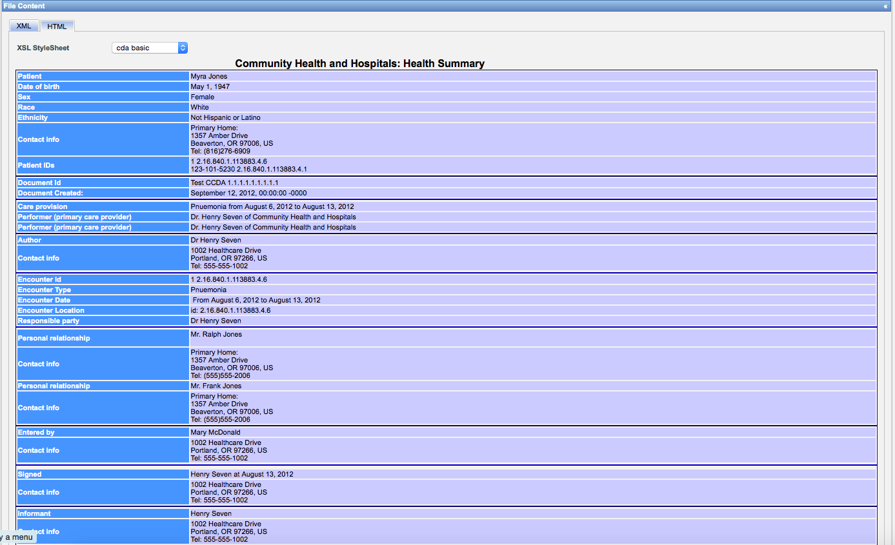

http://gazelle.ihe.net/EVSClient/cda/validator.seam?extension=C-CDA
  - CCDA_CCD_b1_Ambulatoryv2.xml
  - 
   