CDA C-CDA Content Validation of Industry Tooling Summary Document

Last Updated 2015-12-15
The eHealth Exchange Testing Workgroup

http://sequoiaproject.org/
Didi Davis, Director, Testing Programs

CDA Document Samples

- CCDA_CCD_b1_Ambulatory_v2.xml - (https://github.com/chb/sample_ccdas/blob/master/NIST%20Samples/CCDA_CCD_b1_Ambulatory_v2.xml)
- CCDA_CCD_170.314b2_AmbulatoryTOC.xml
https://github.com/gecole/HL7-Task-Force-Examples/blob/master/170.314b2_AmbulatoryToC.xml
- CCDA_CCD_b1_InPatient_v2.xml – (https://github.com/chb/sample_ccdas/blob/master/NIST%20Samples/CCDA_CCD_b1_InPatient_v2.xml)
- TOC_CCDA_CCD_CompGuideSample_FullXML.xml
(https://github.com/chb/sample_ccdas/blob/master/Transitions%20of%20Care%20Samples/ToC_CCDA_CCD_CompGuideSample_FullXML.xml)
- AllNegativeTestingCCDAs.zip

CDA C-CDA CCD Content Validation Tools

http://transport-testing.nist.gov/ttt/

_{CCDA_CCD_b1_Ambulatoryv2.xml}
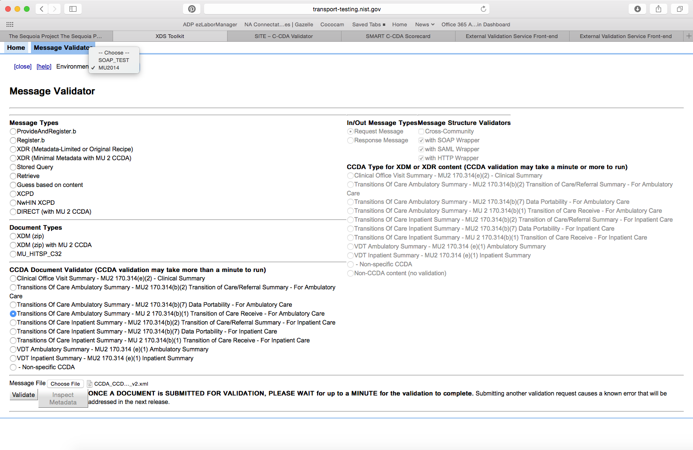
The validation was run for the above file and generated the following report: 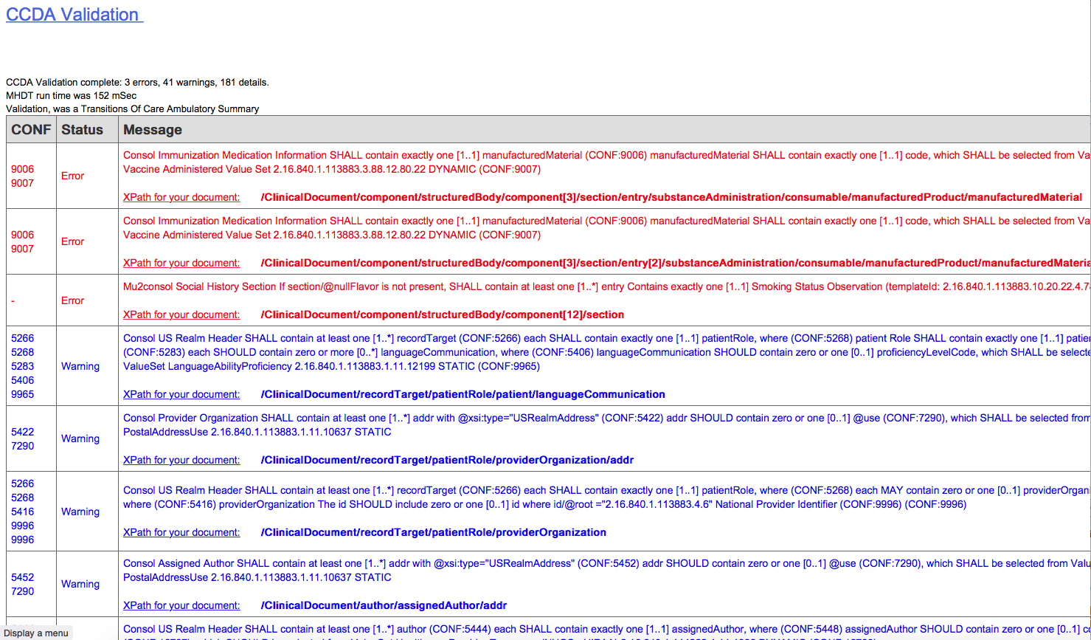

170.314b2_AmbulatoryTOC.xml
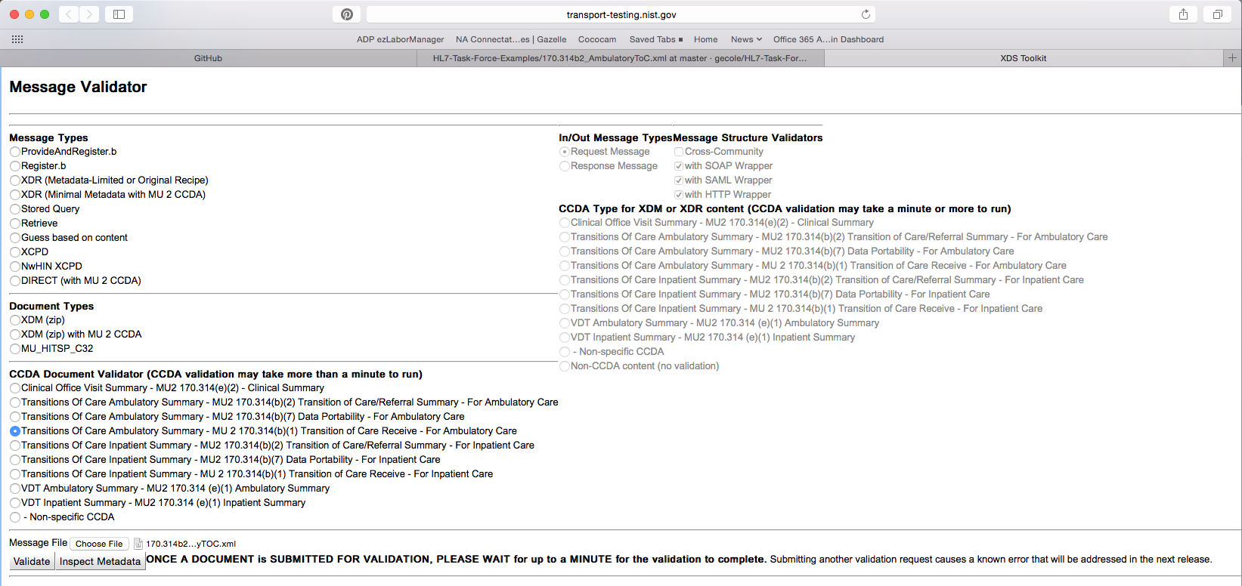
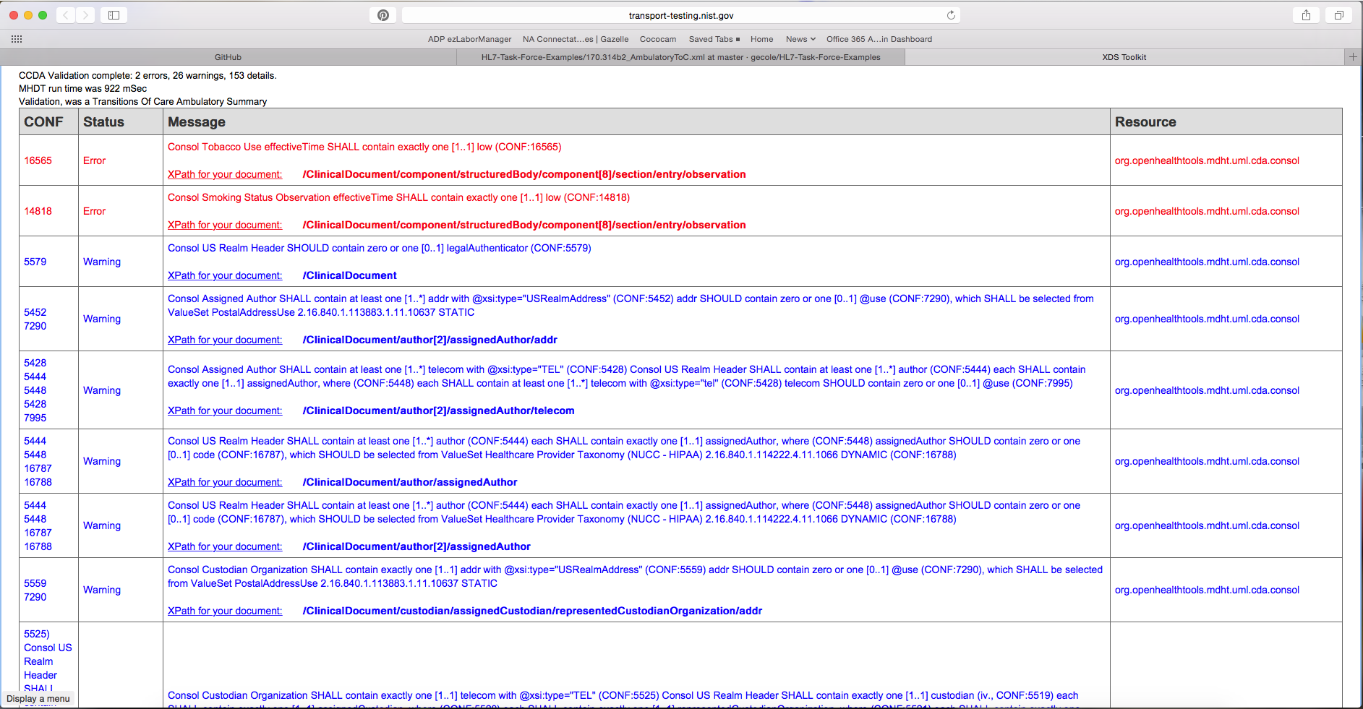

CCDA_CCD_b1_InPatient_v2.xml
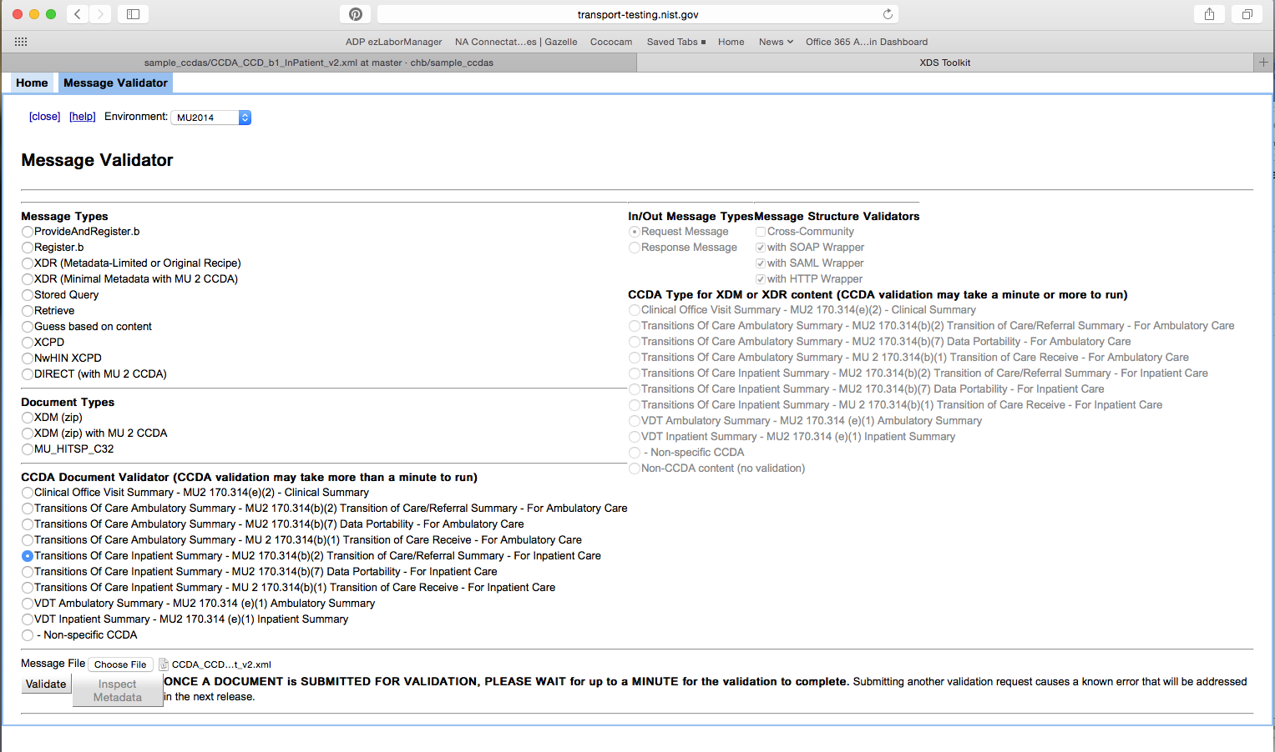
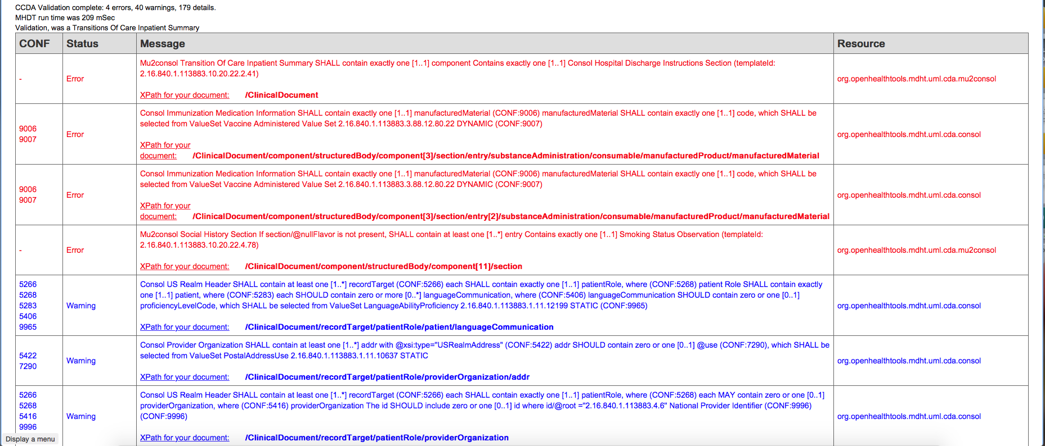

TOC_CCDA_CCD_CompGuideSample_FullXML.xml
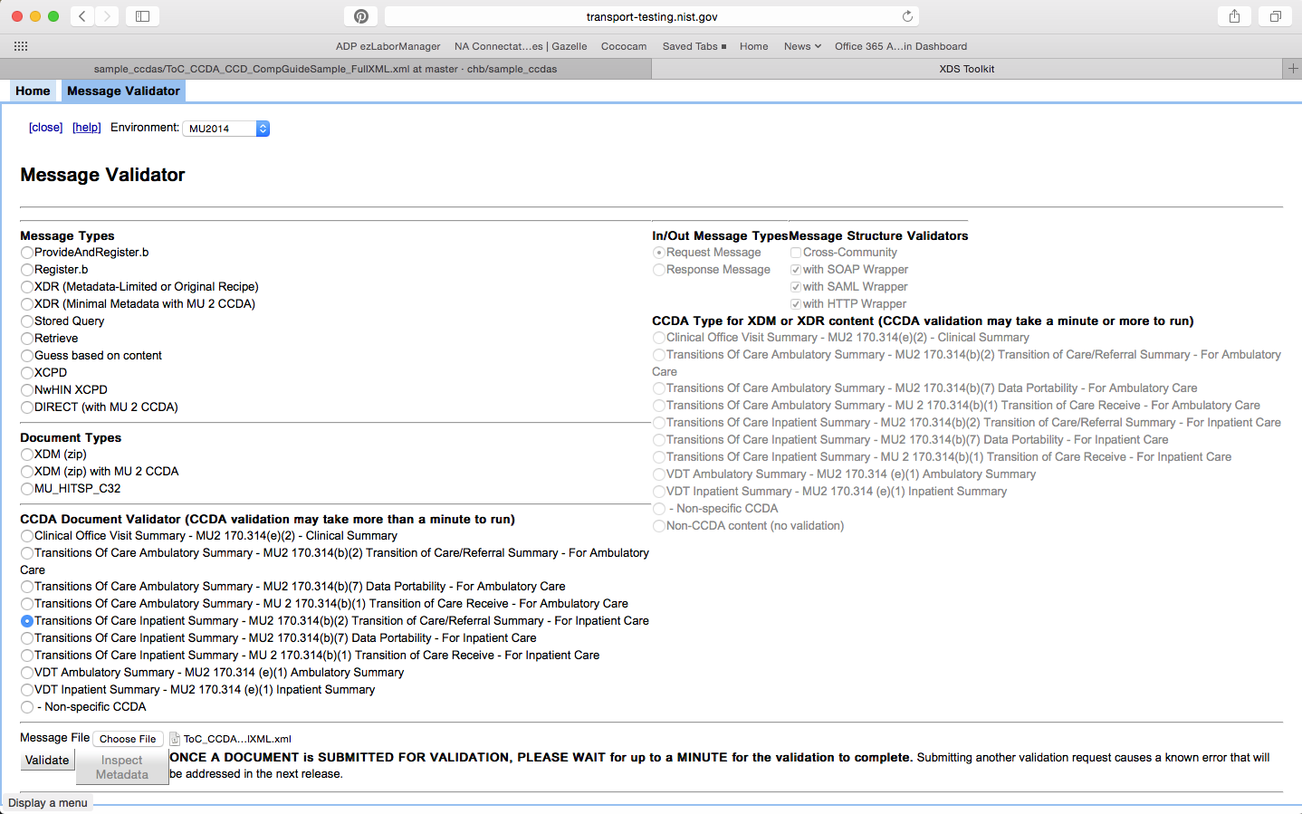
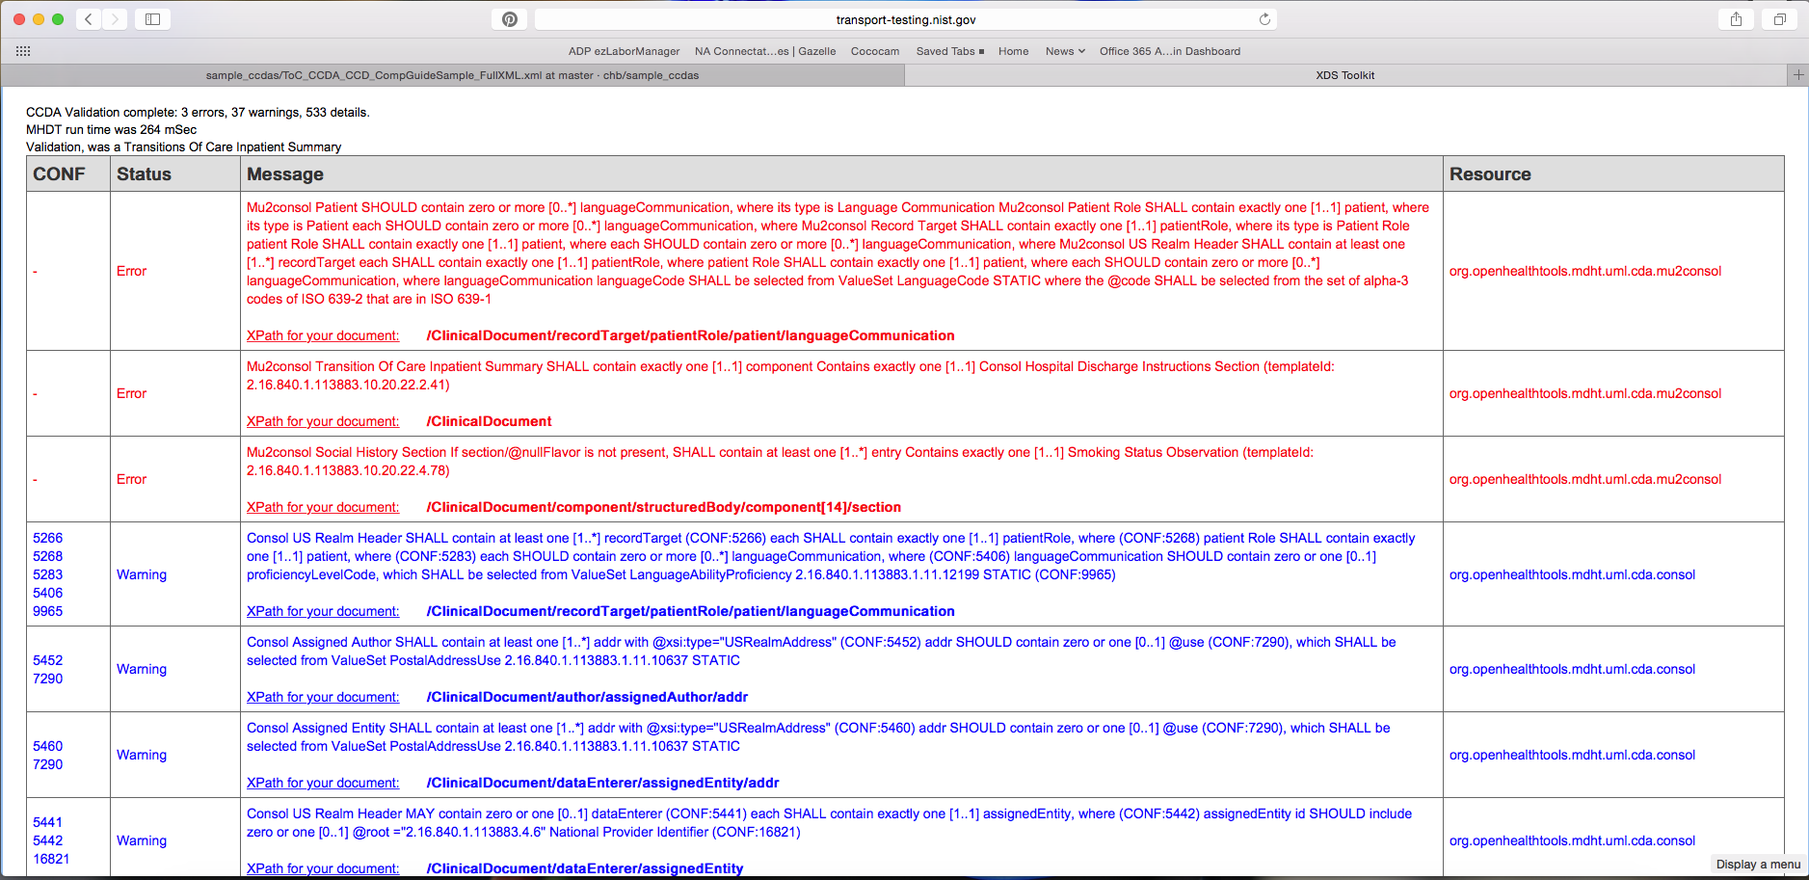

AllNegativeTestingCCDAs.zip

http://sitenv.org/c-cda-validator

CCDA_CCD_b1_Ambulatoryv2.xml
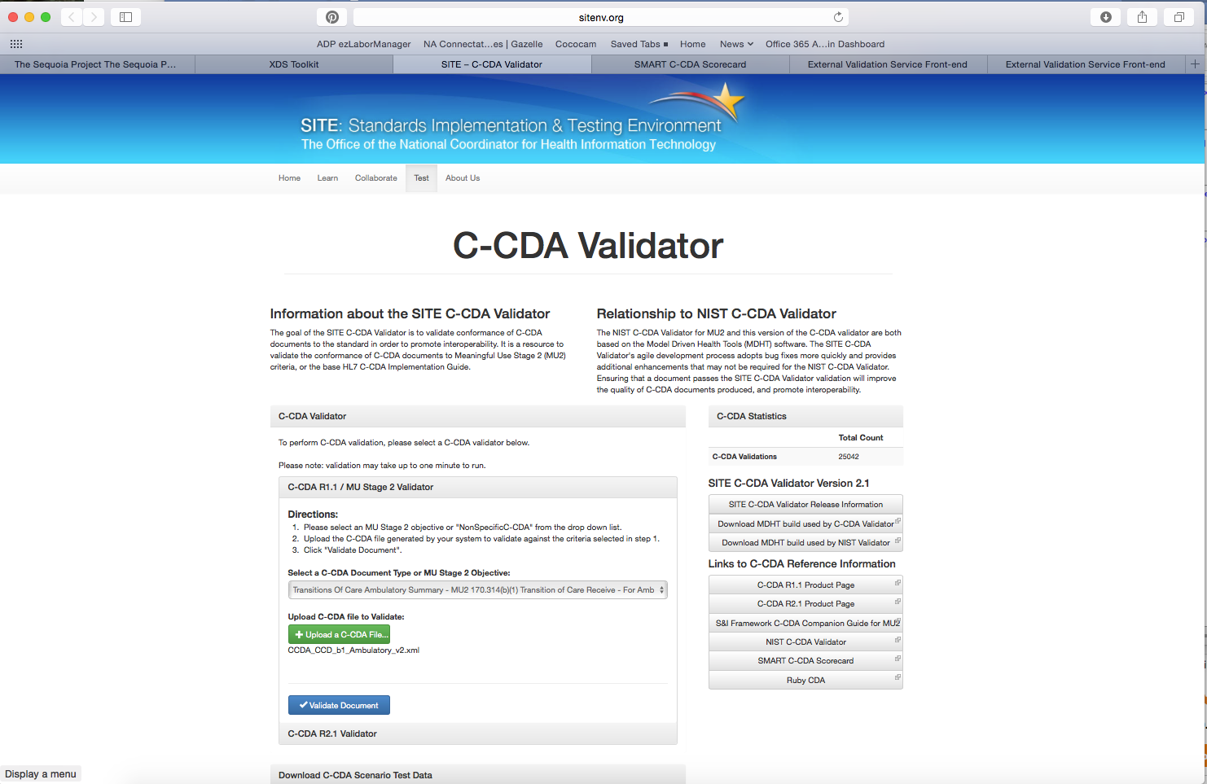
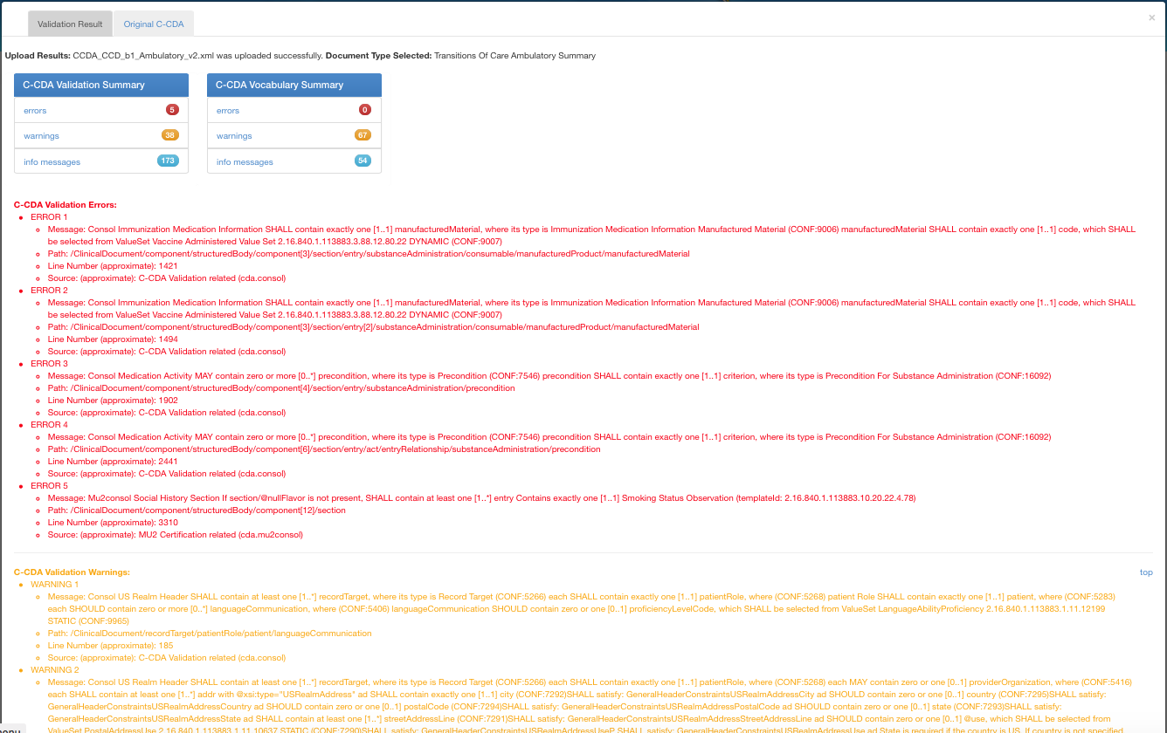
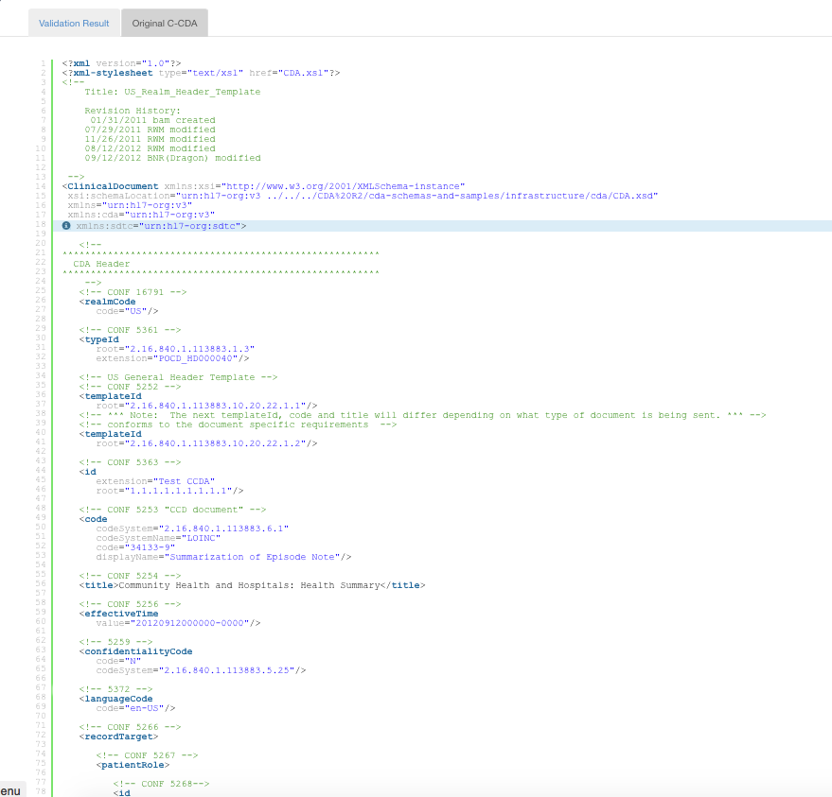

170.314b2_AmbulatoryTOC.xml
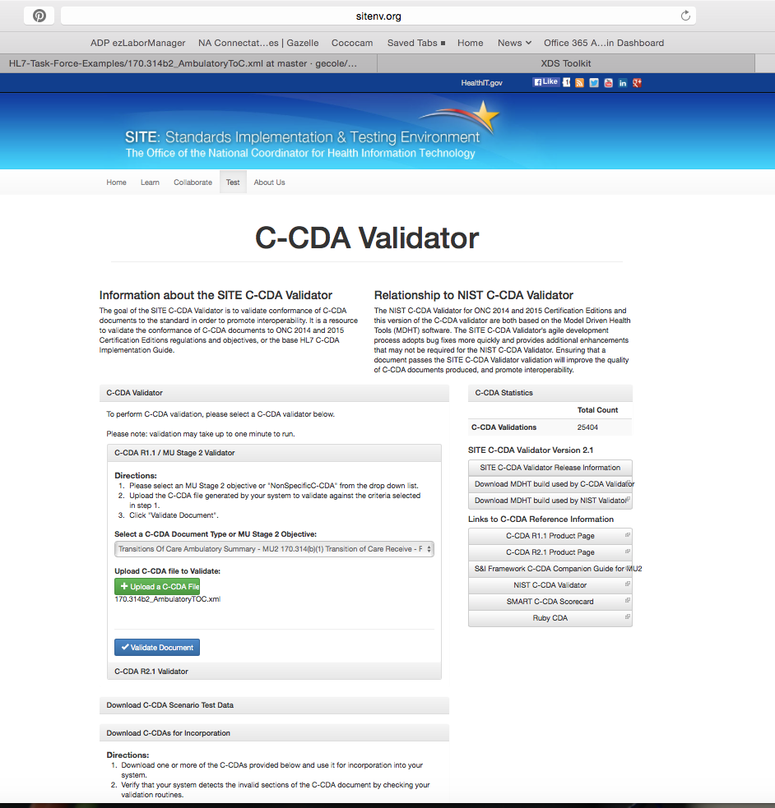
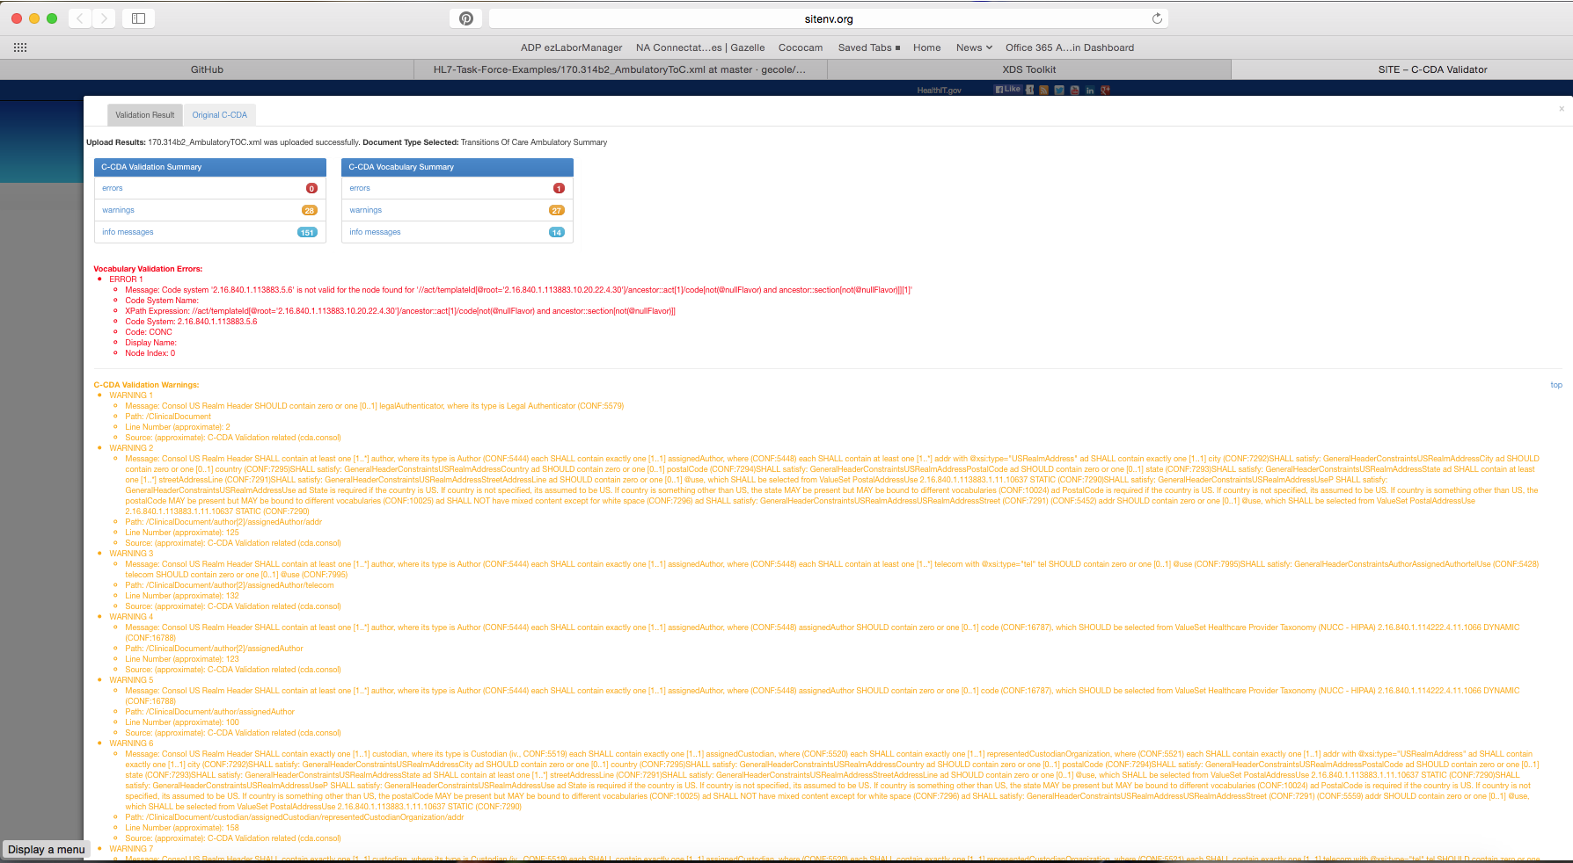

CCDA_CCD_b1_InPatient_v2.xml
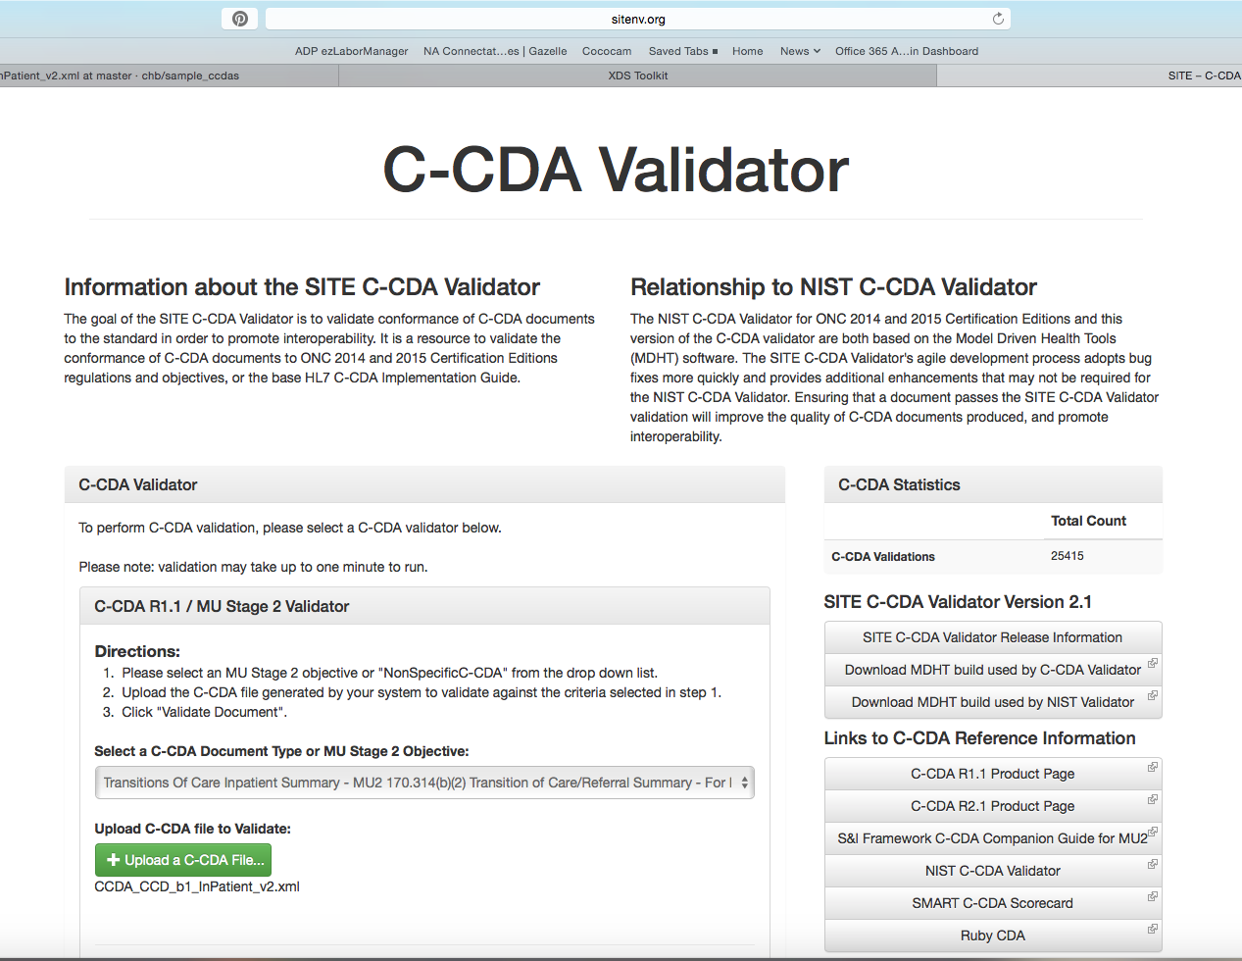
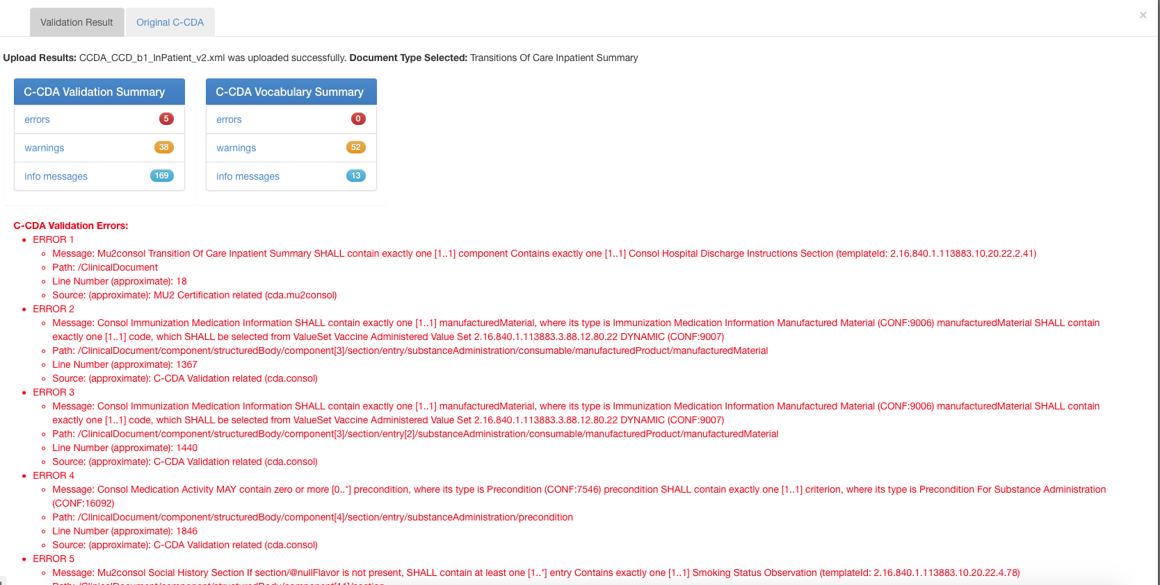

TOC_CCDA_CCD_CompGuideSample_FullXML.xml
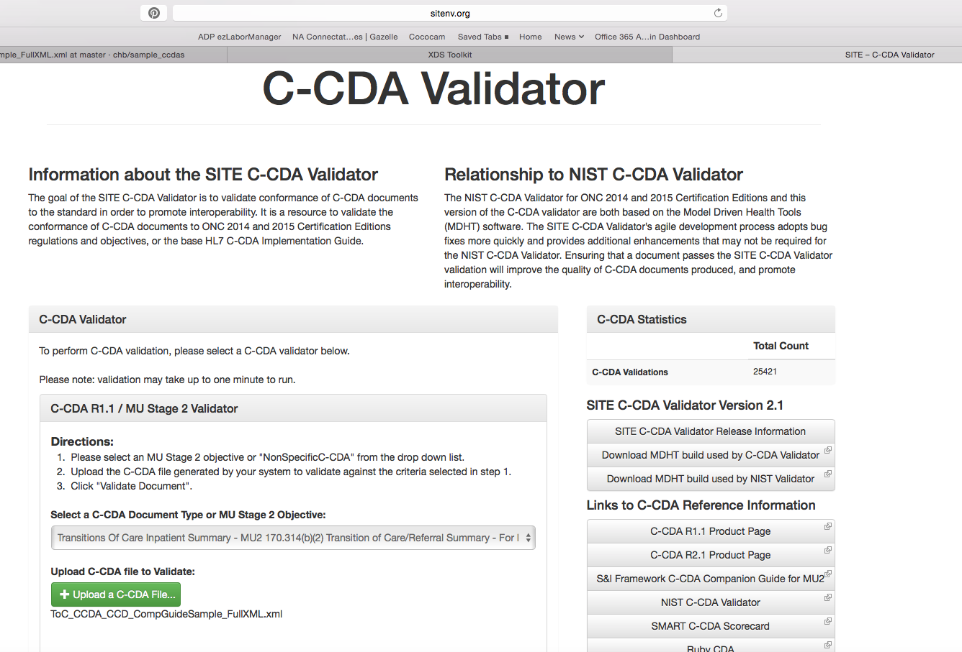
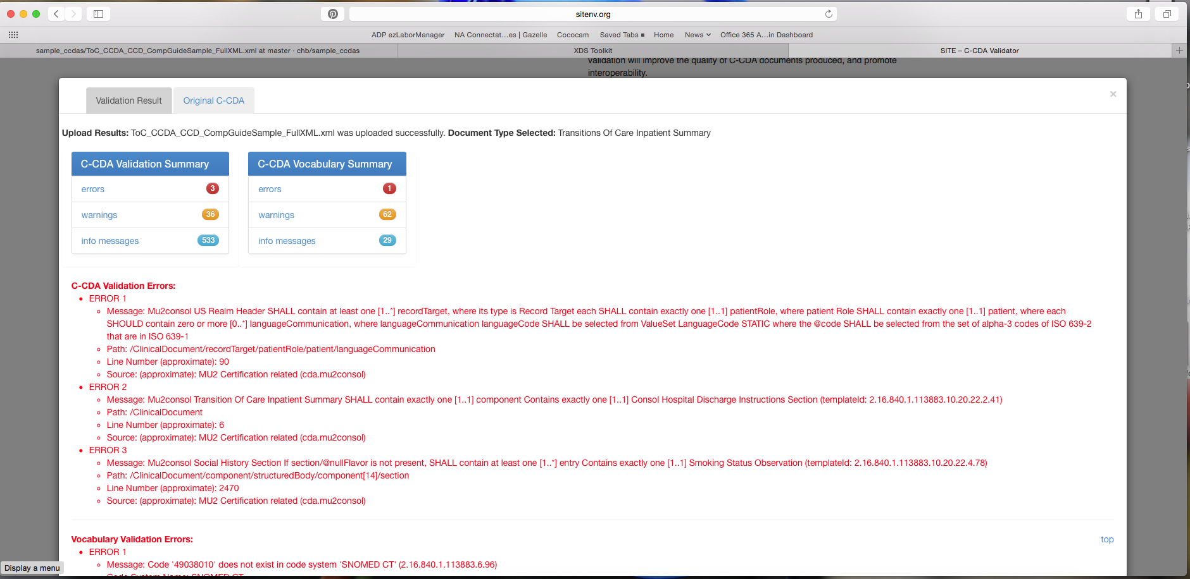

AllNegativeTestingCCDAs.zip

http://ccda-scorecard.smartplatforms.org/static/ccdaScorecard/#/

CCDA_CCD_b1_Ambulatoryv2.xml
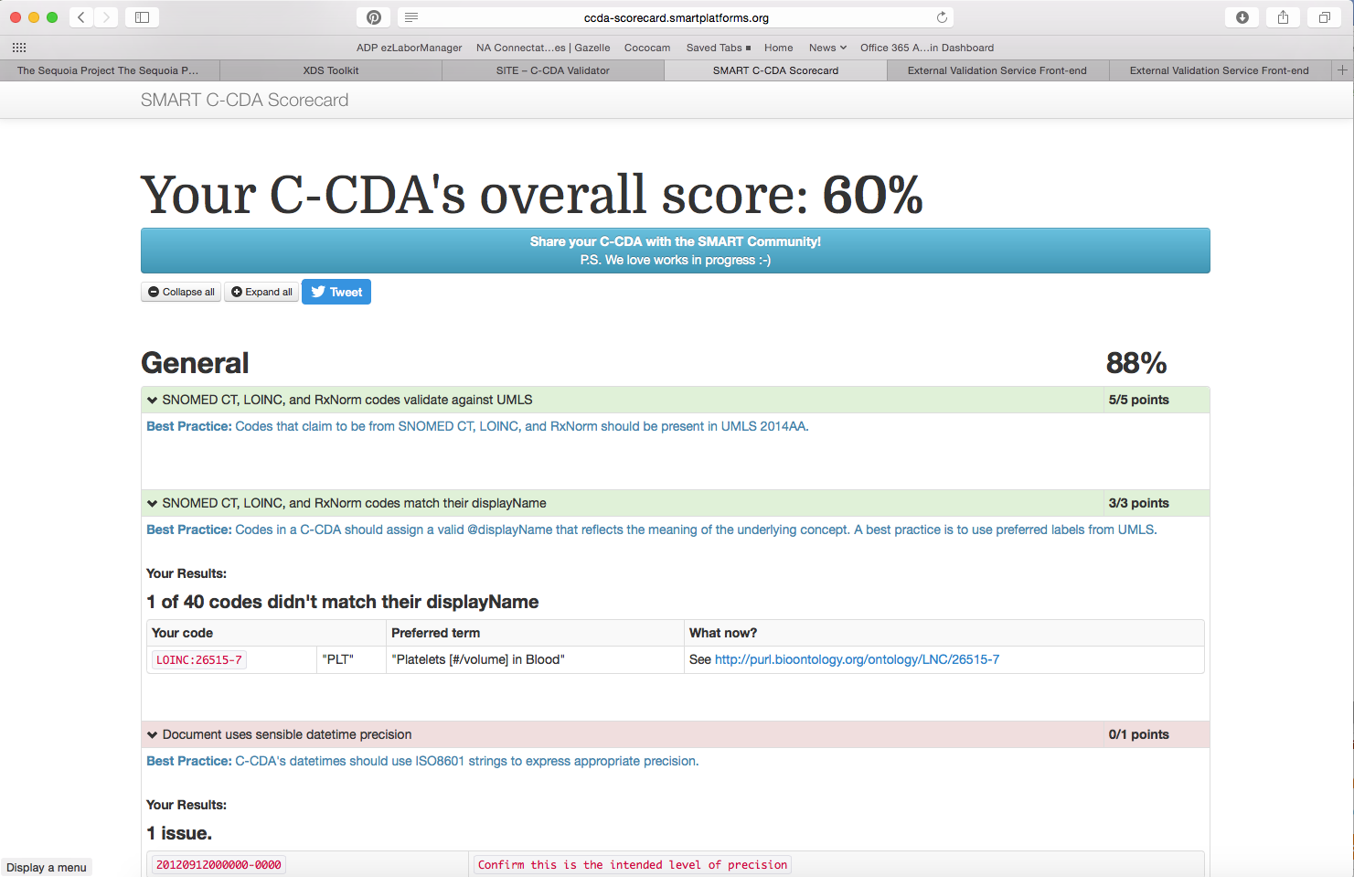

170.314b2_AmbulatoryTOC.xml
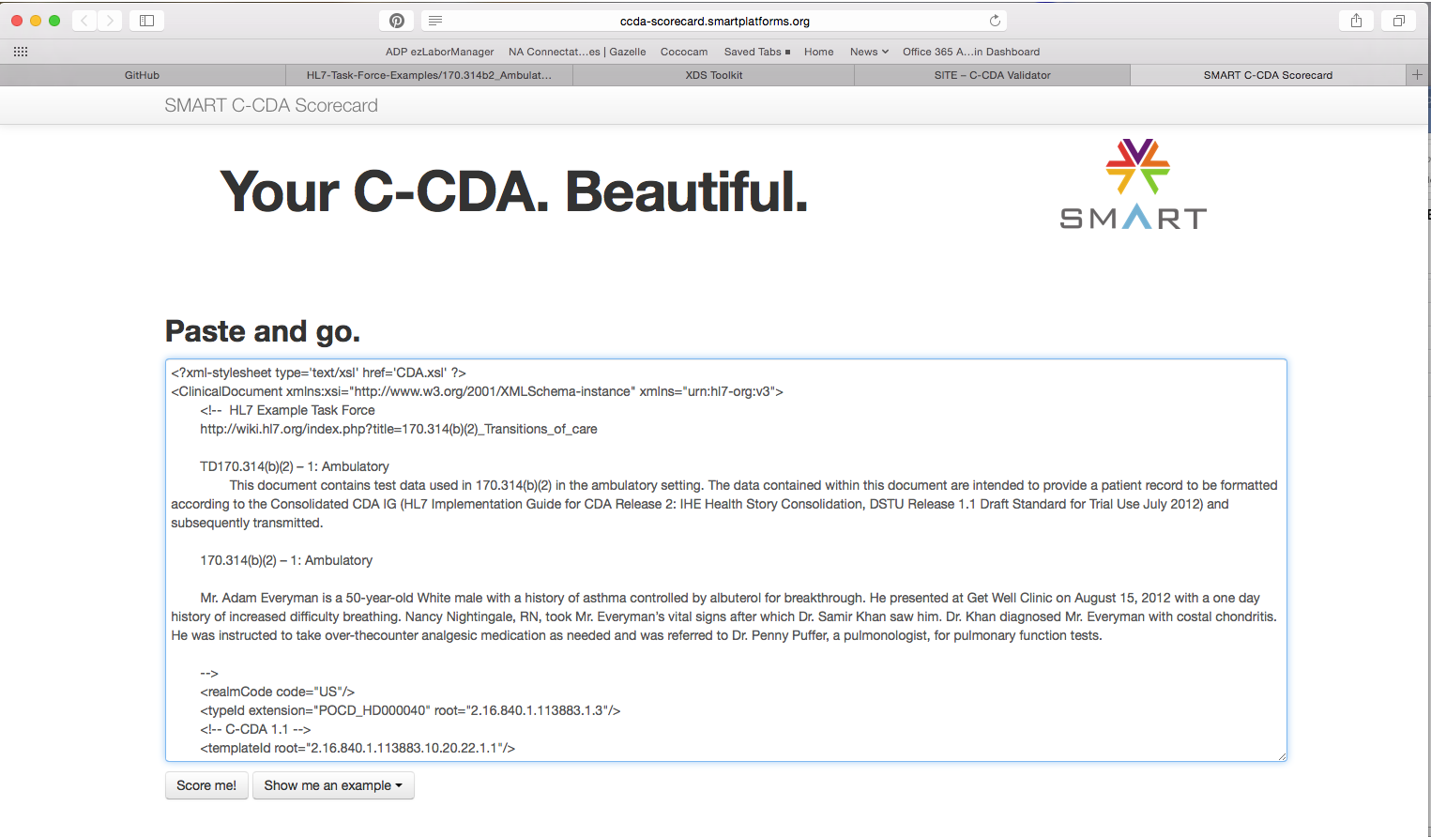
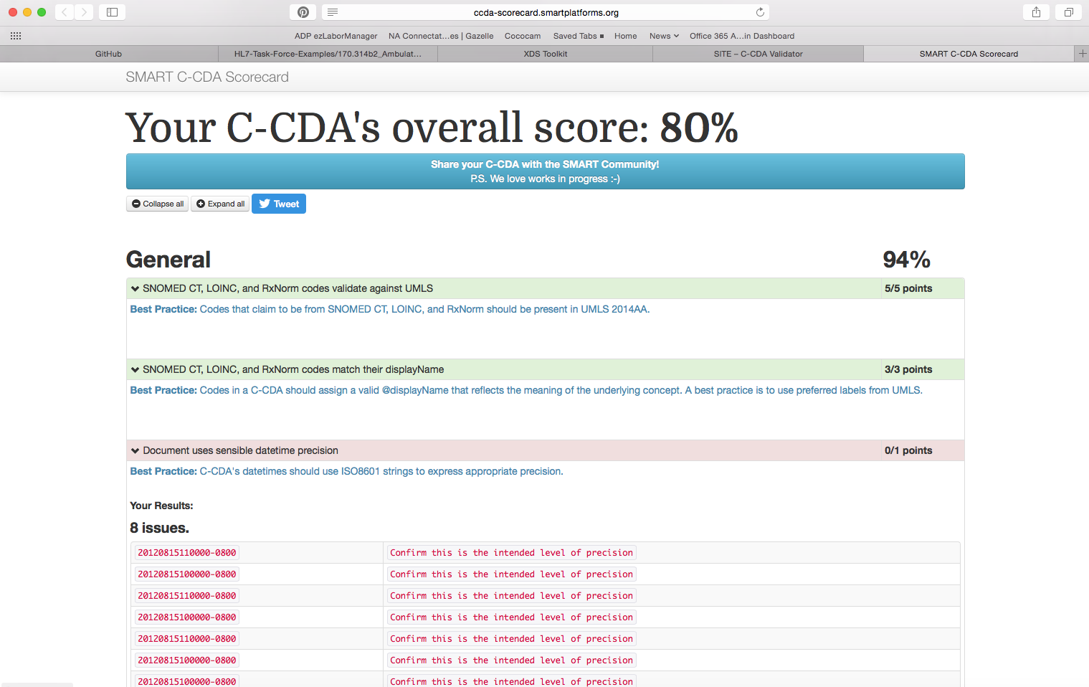

CCDA_CCD_b1_InPatient_v2.xml
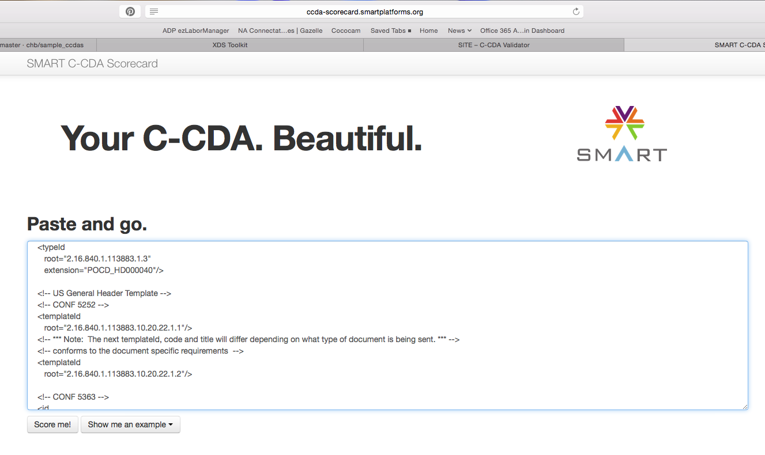
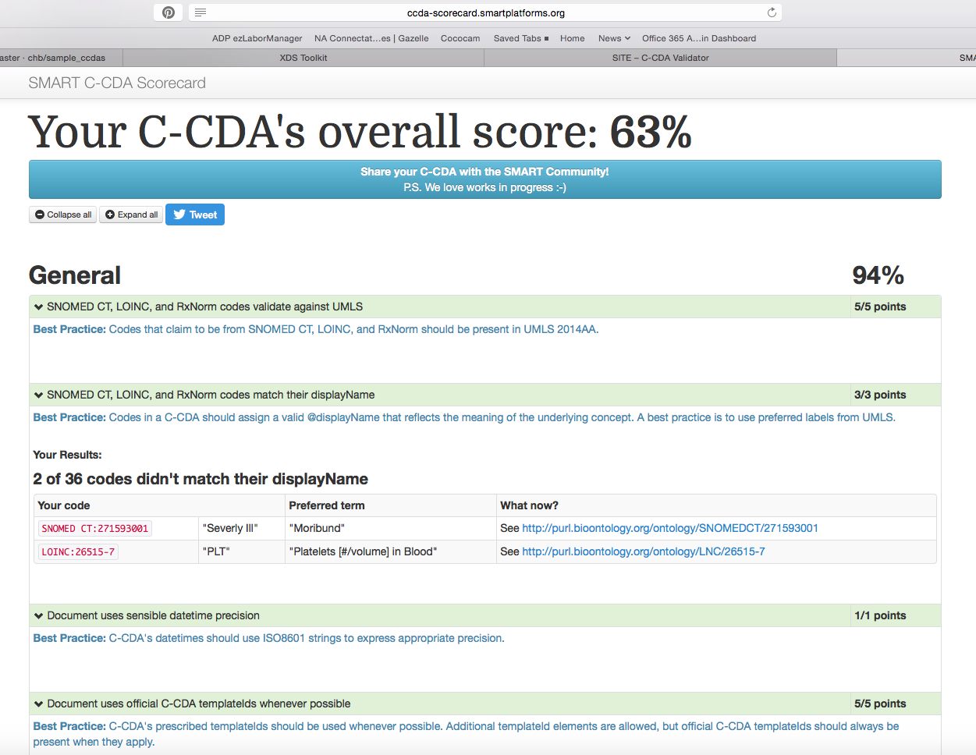

TOC_CCDA_CCD_CompGuideSample_FullXML.xml
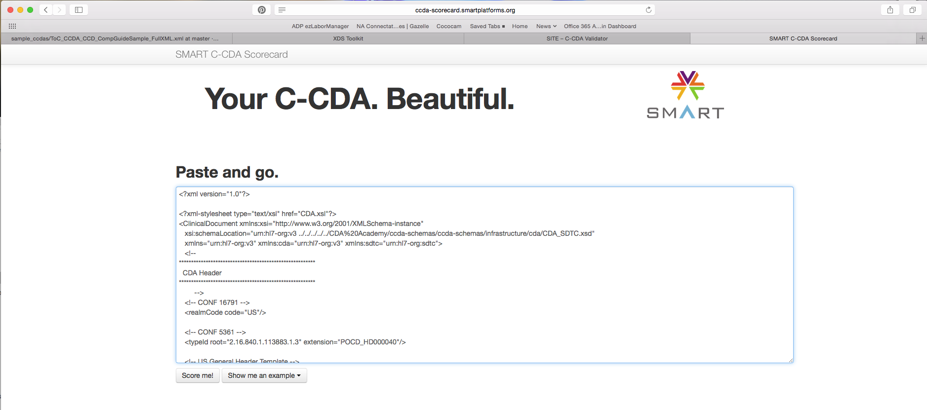
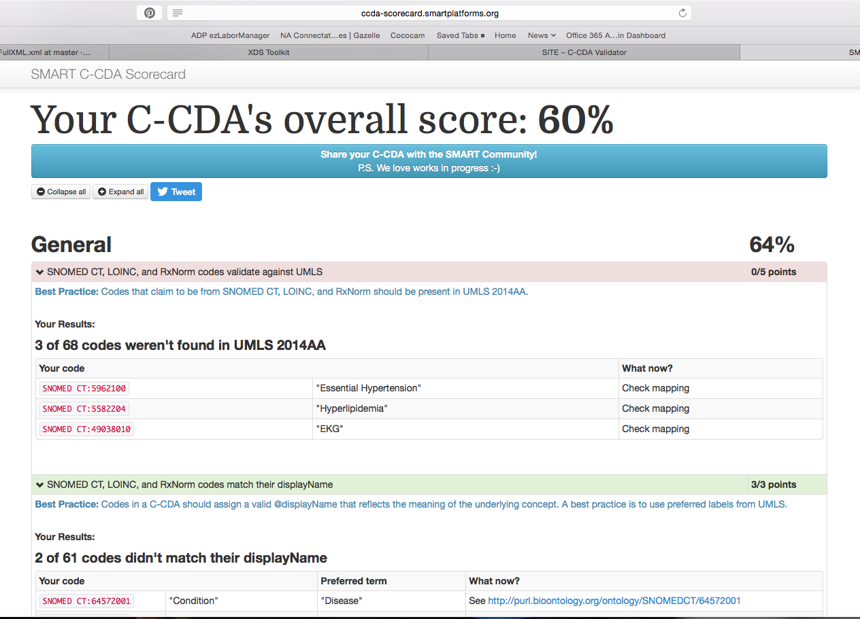

AllNegativeTestingCCDAs.zip

http://gazelle.ihe.net/EVSClient

CCDA_CCD_b1_Ambulatoryv2.xml
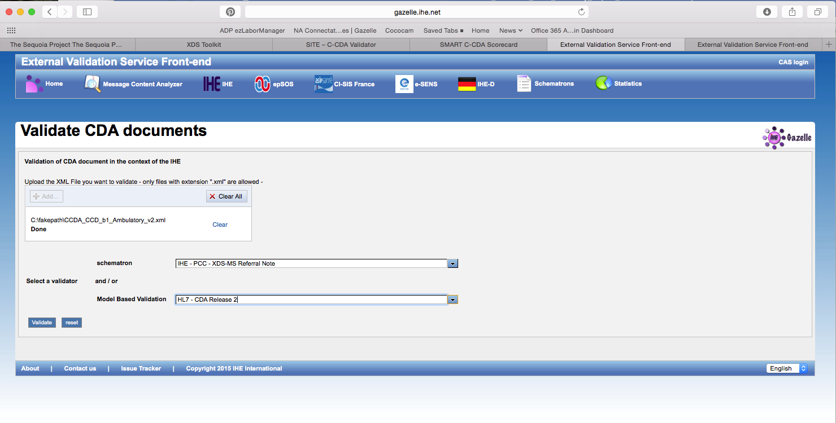
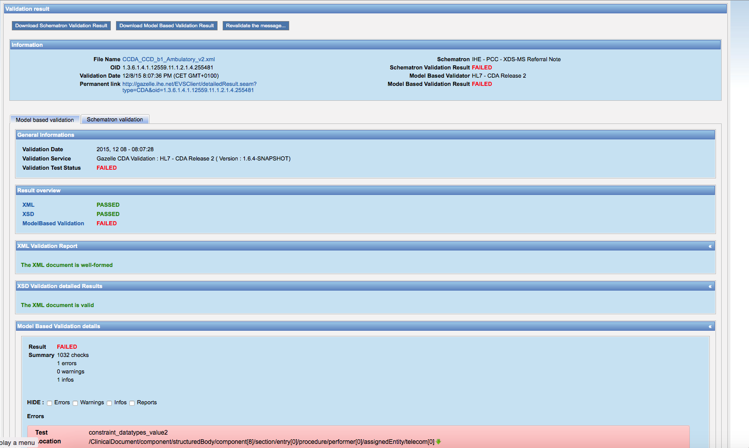
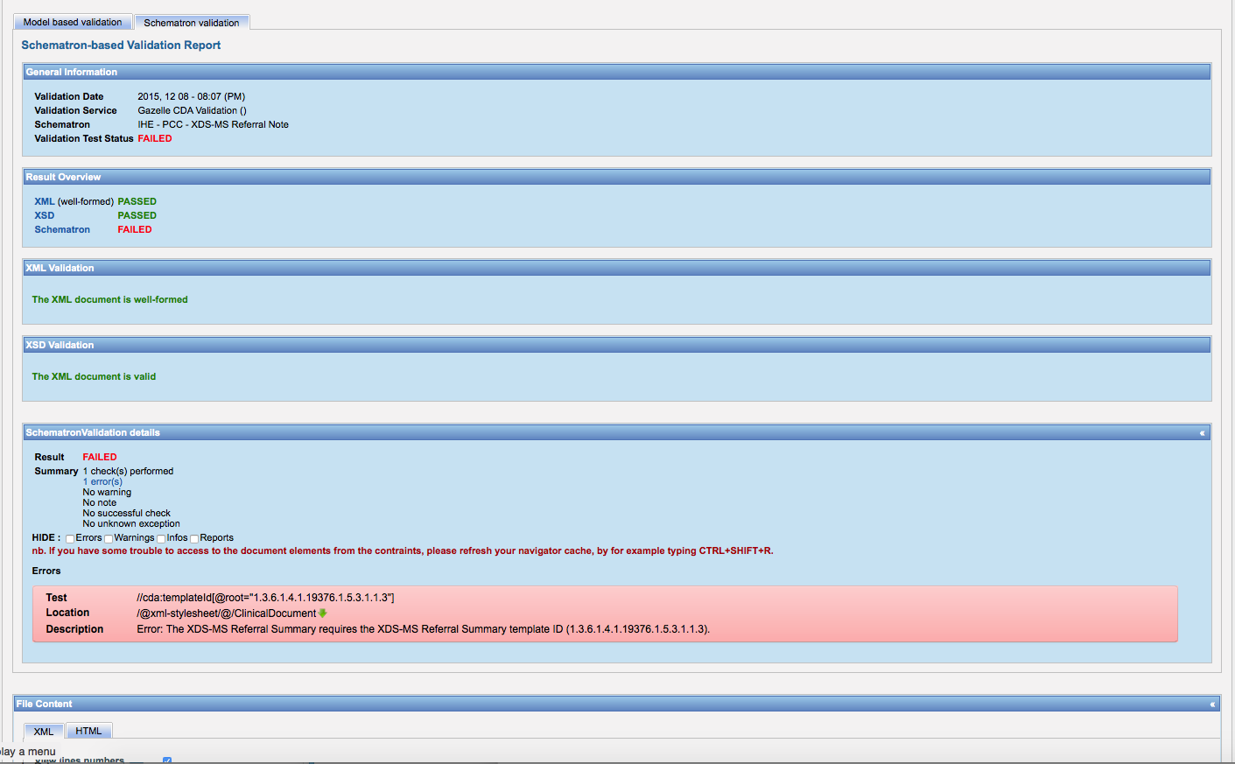
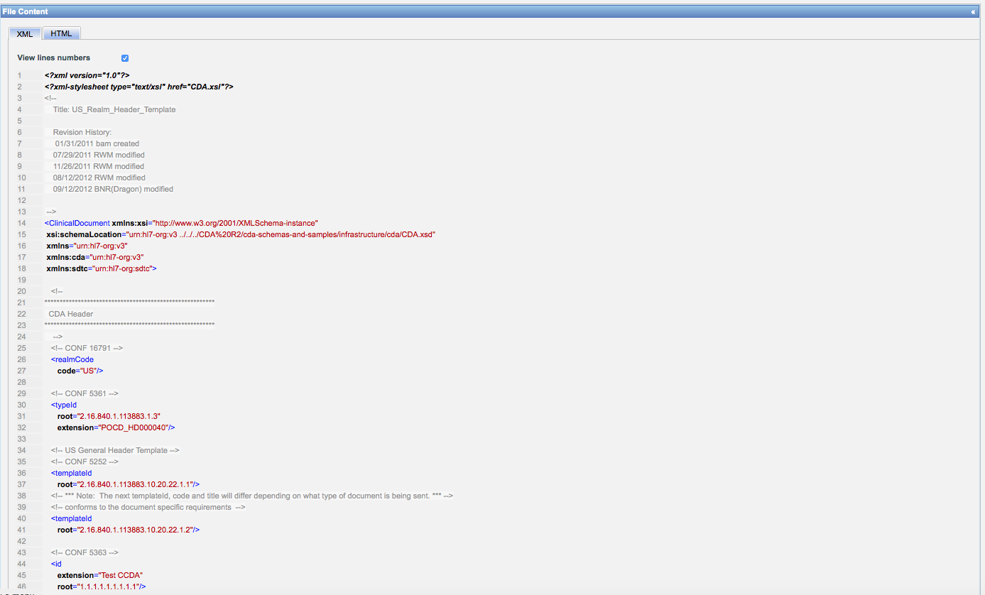
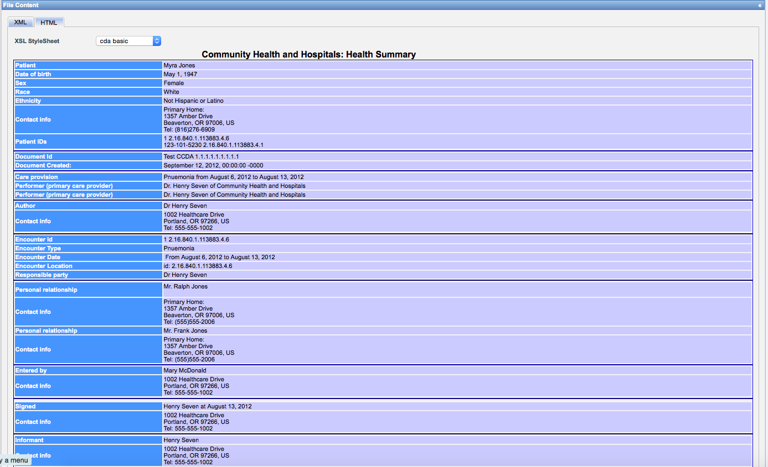

170.314b2_AmbulatoryTOC.xml
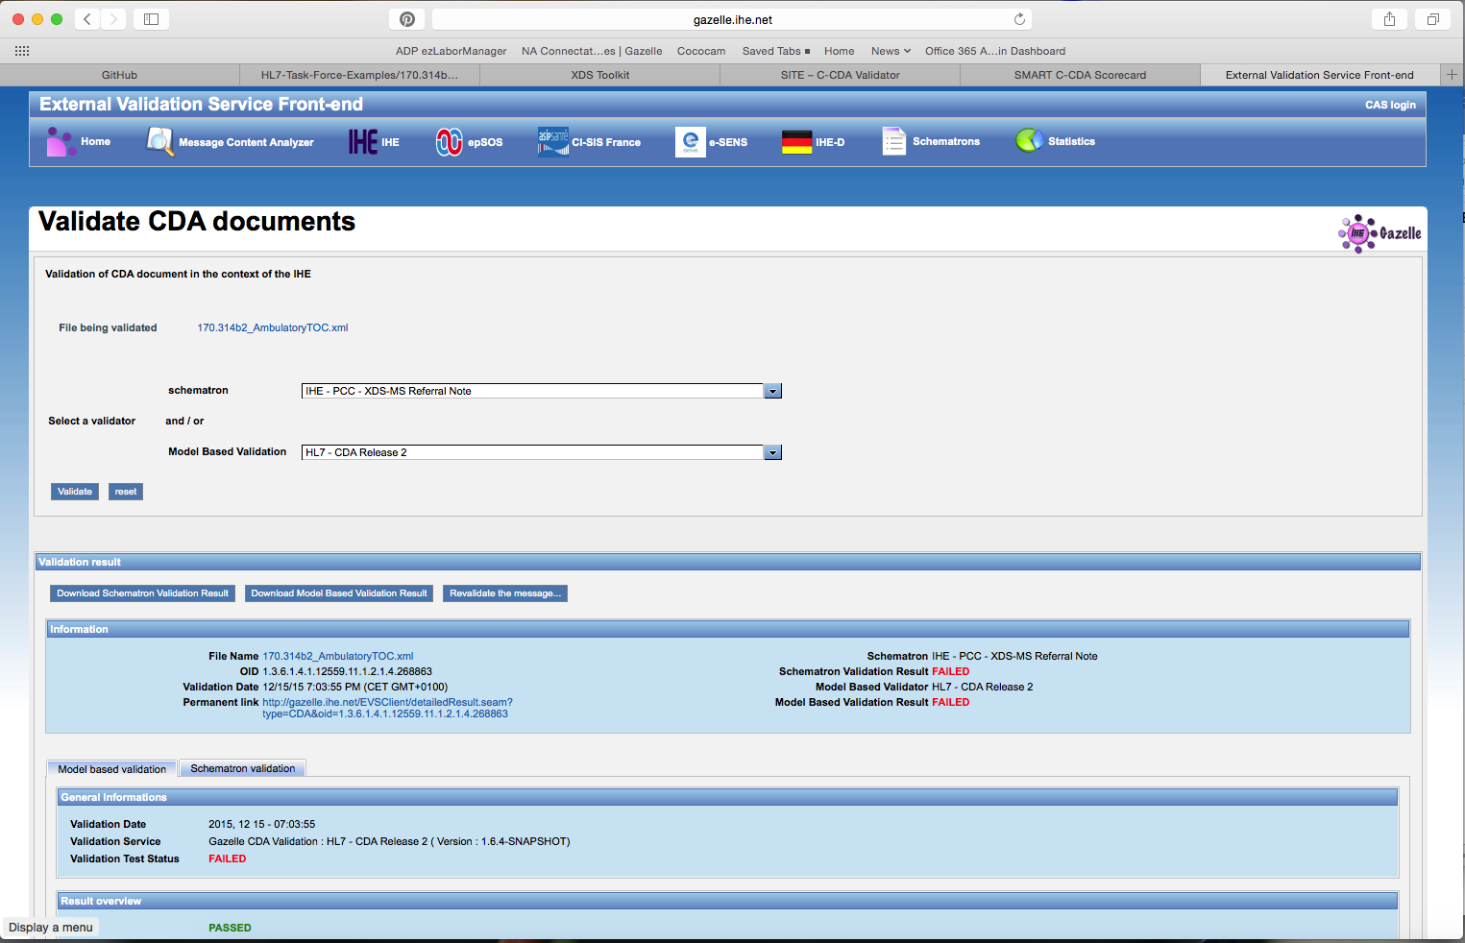
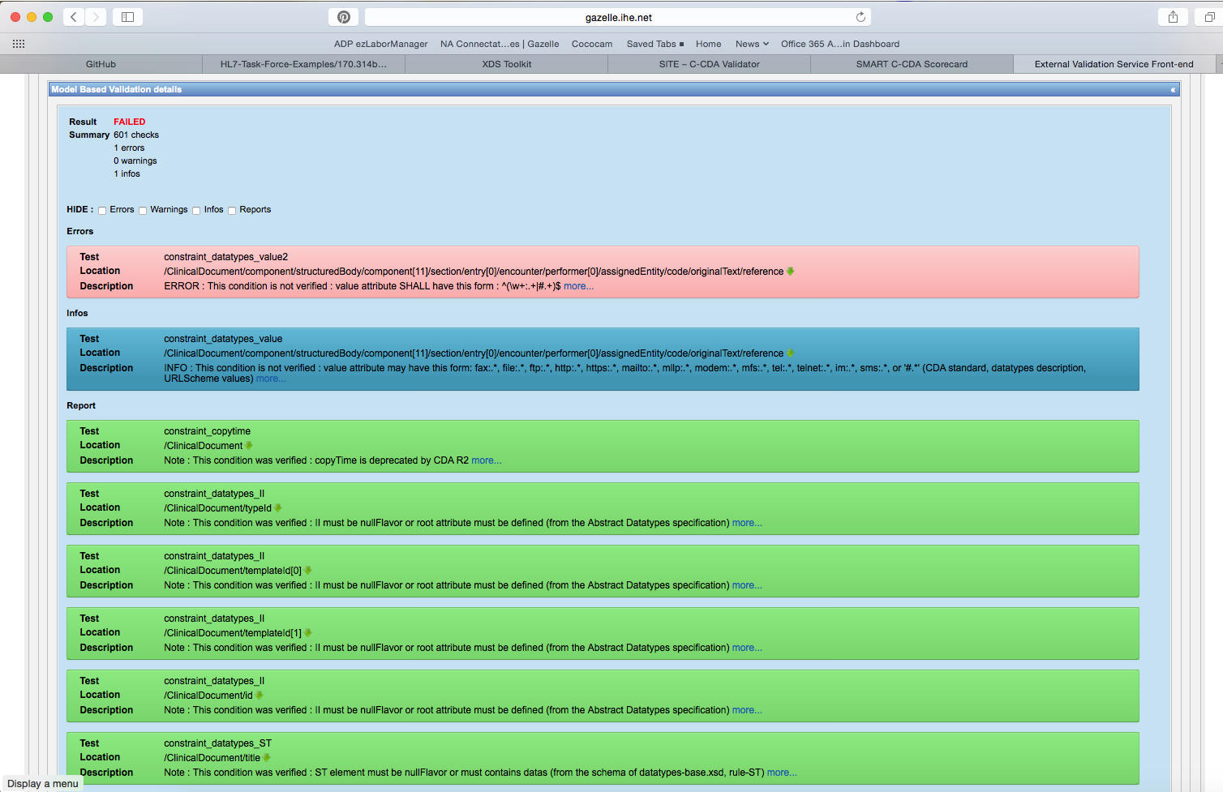

CCDA_CCD_b1_InPatient_v2.xml
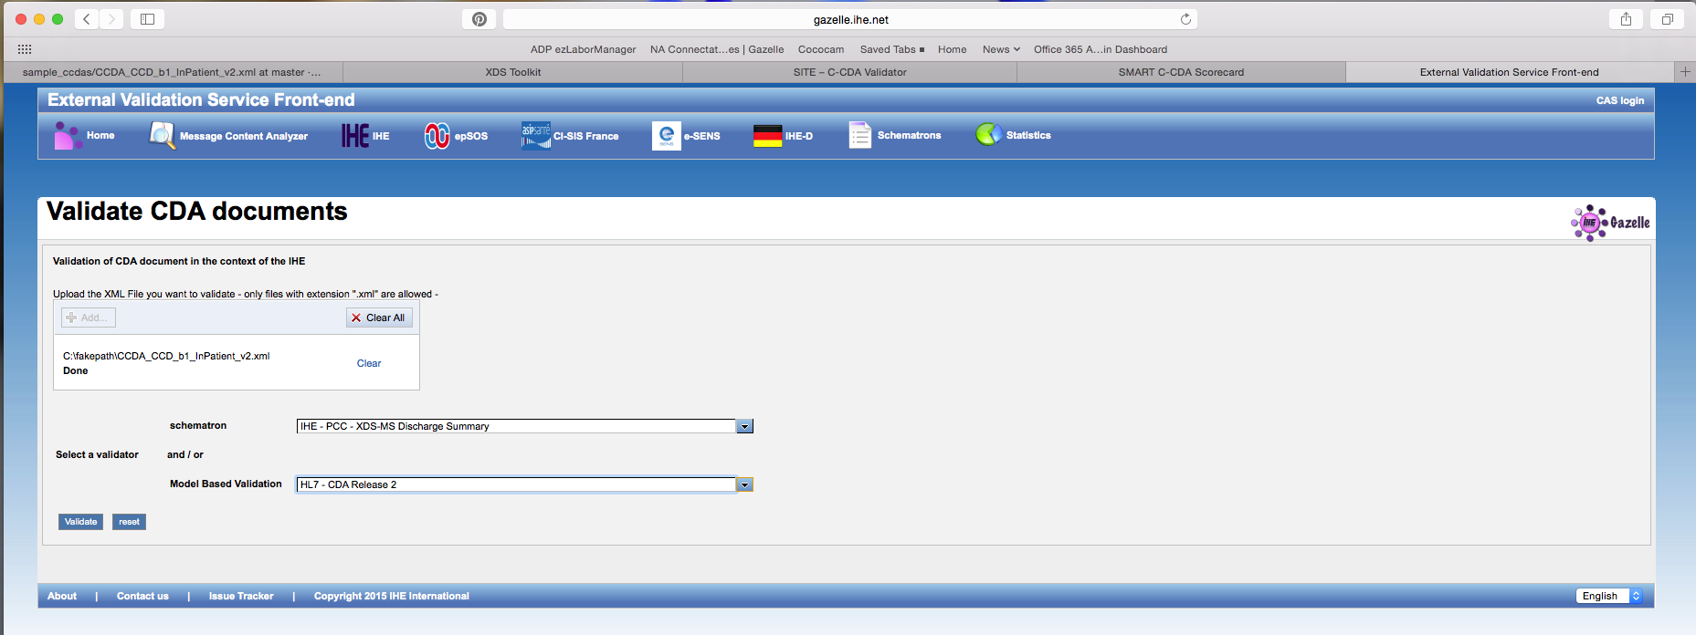
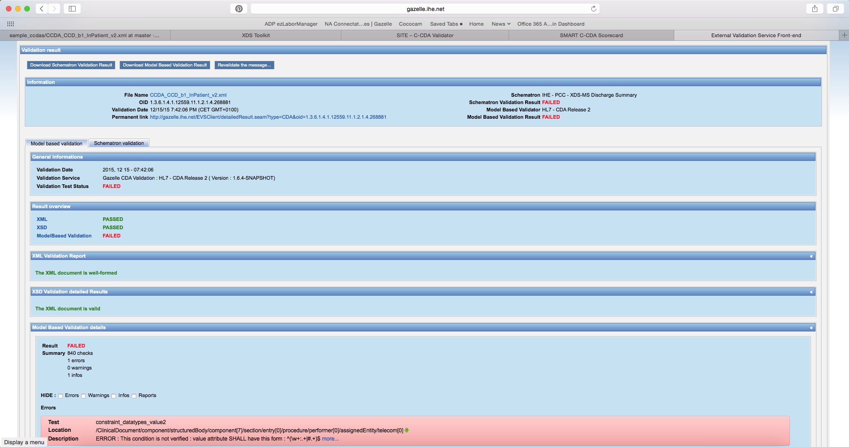

TOC_CCDA_CCD_CompGuideSample_FullXML.xml
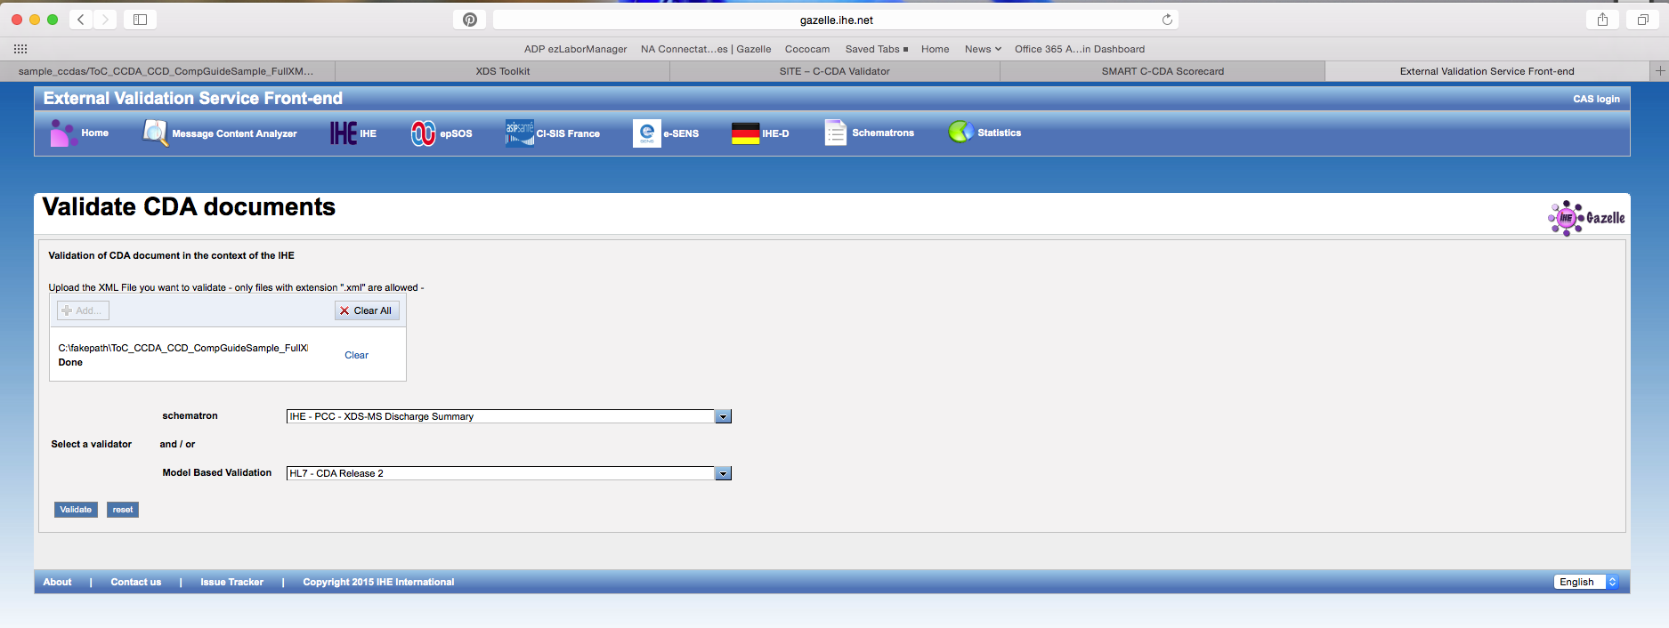
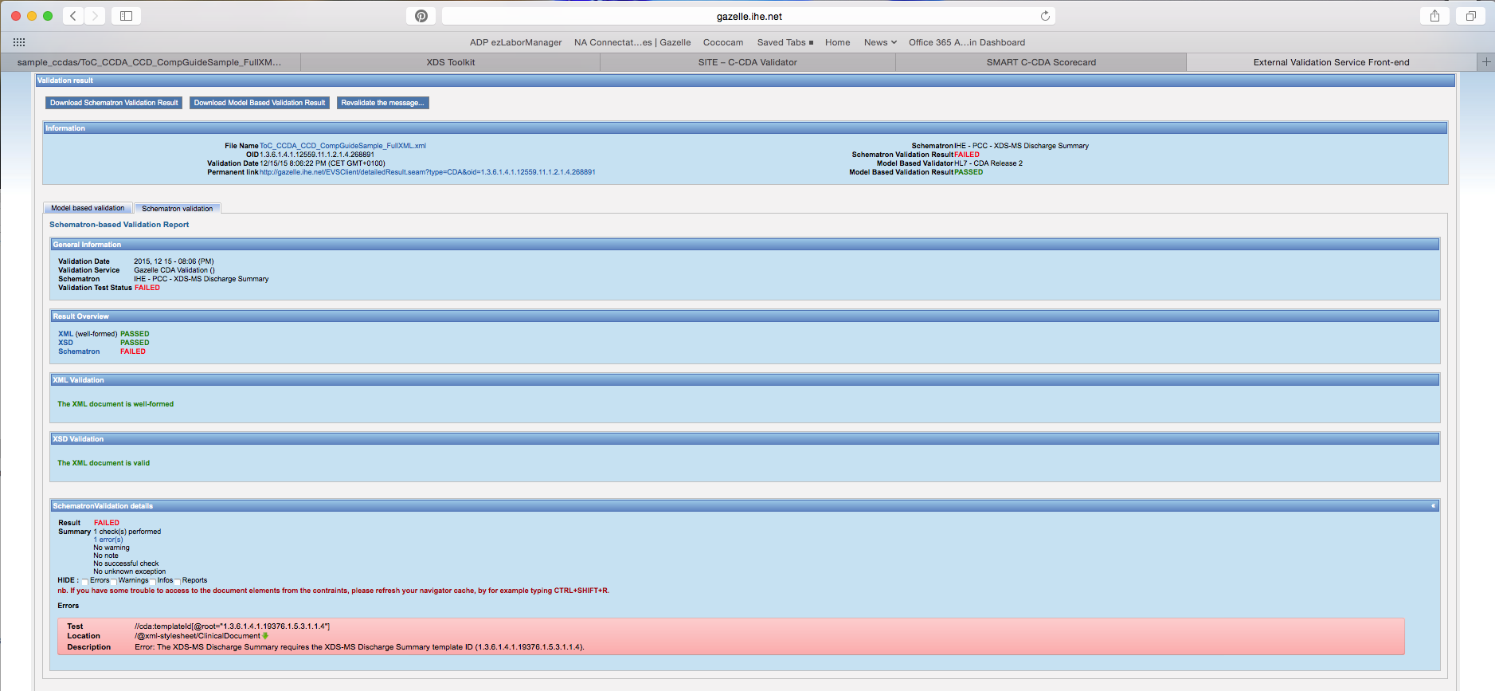

AllNegativeTestingCCDAs.zip

http://gazelle.ihe.net/EVSClient/cda/validator.seam?extension=C-CDA

CCDA_CCD_b1_Ambulatoryv2.xml
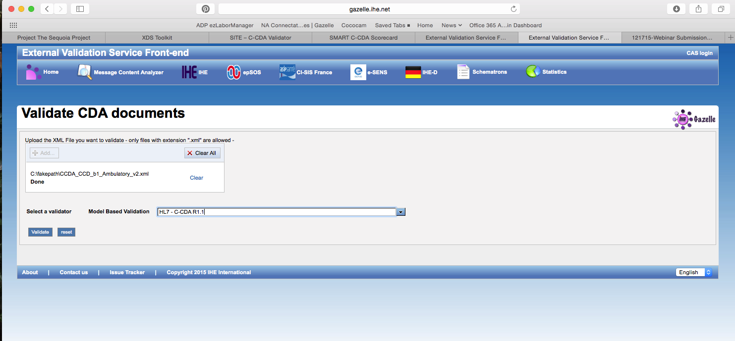
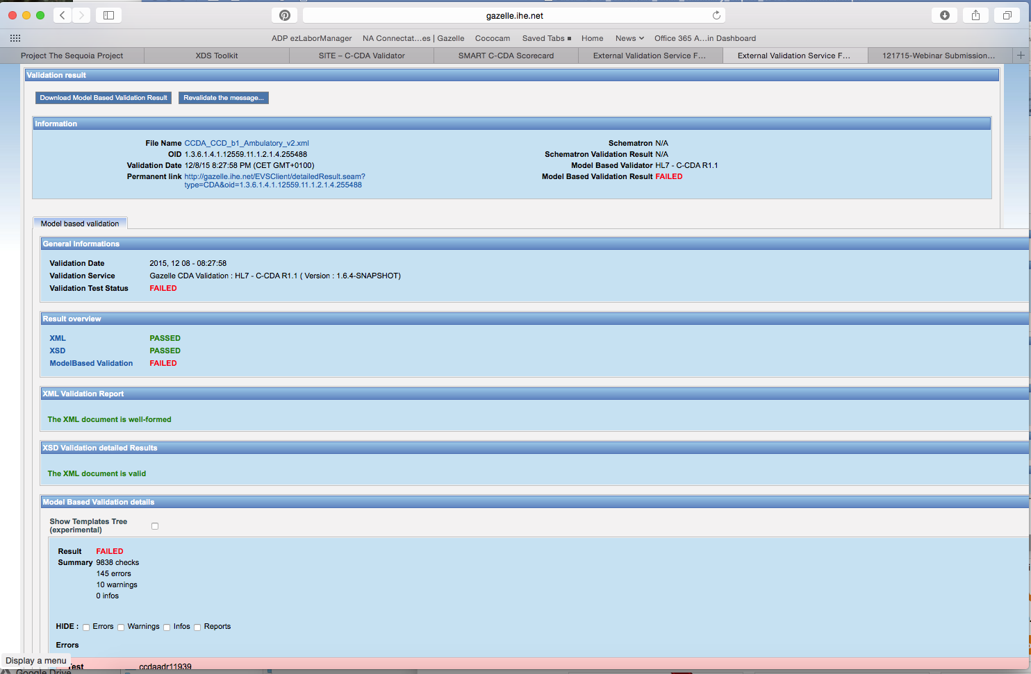

170.314b2_AmbulatoryTOC.xml

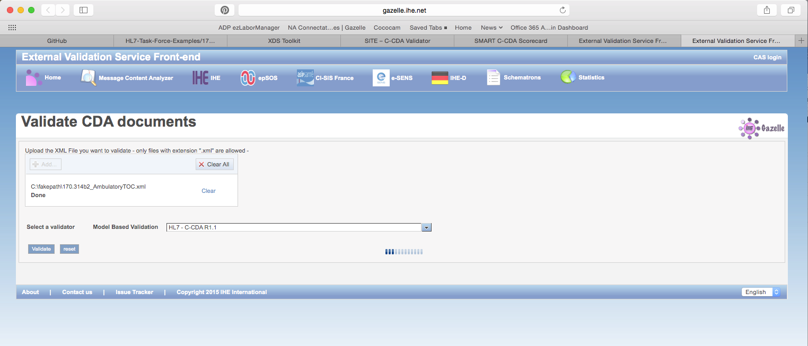
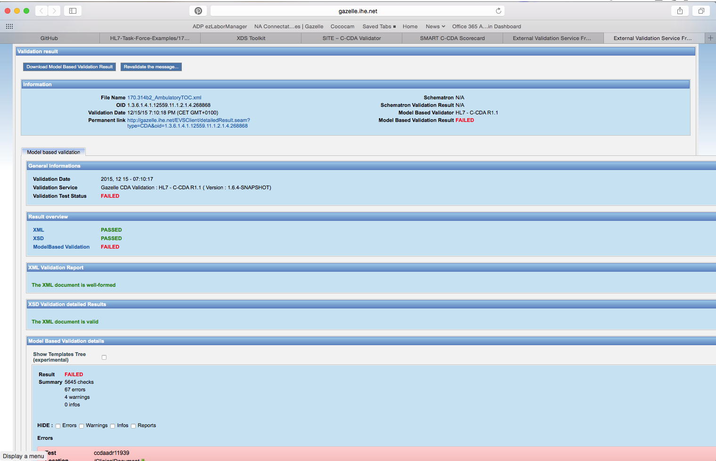
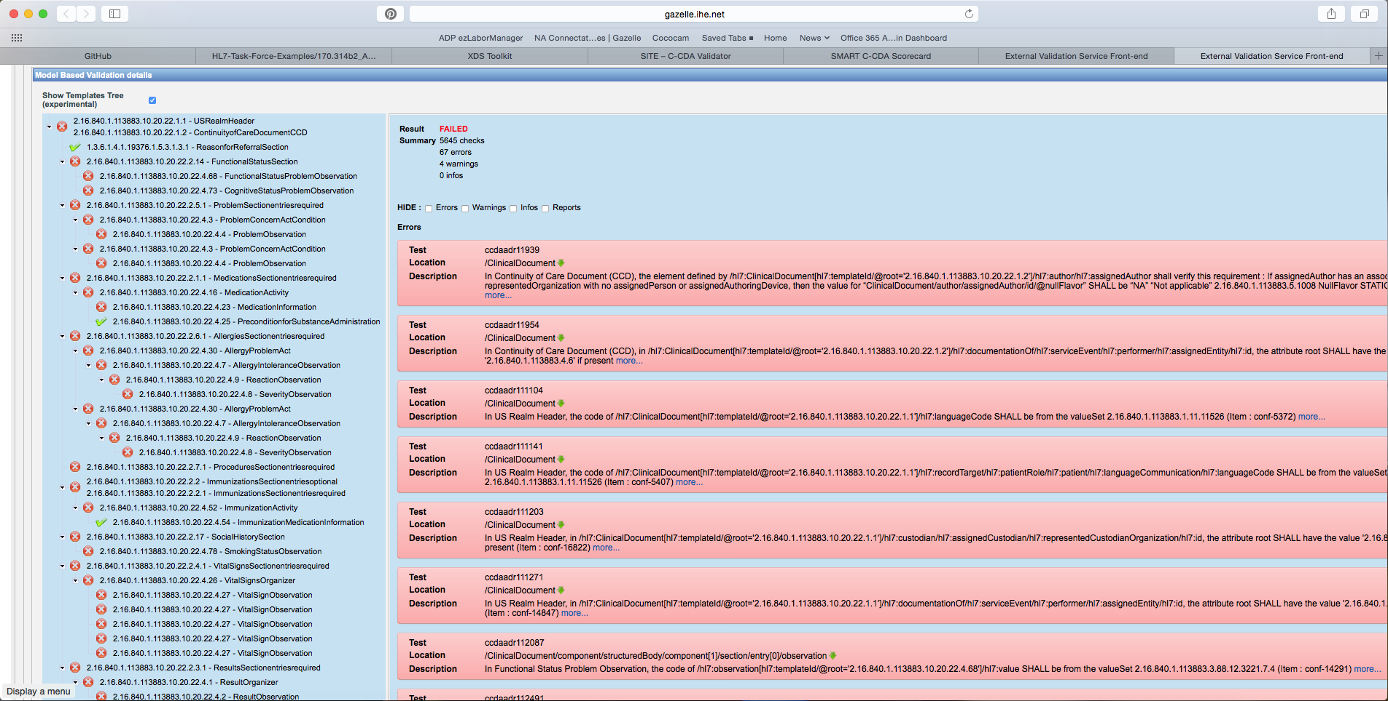

CCDA_CCD_b1_InPatient_v2.xml
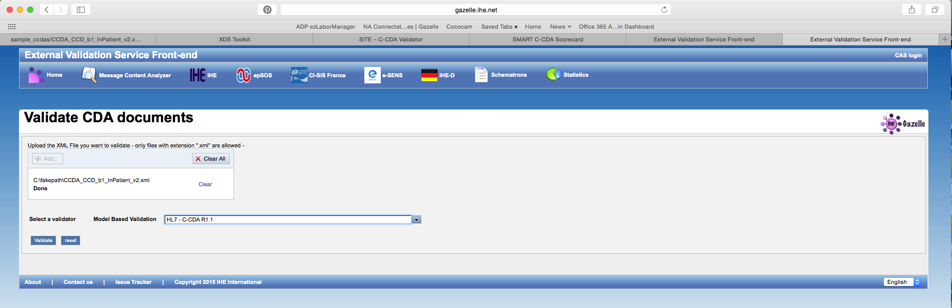
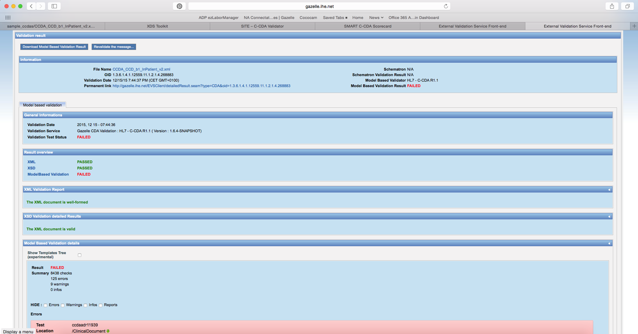

TOC_CCDA_CCD_CompGuideSample_FullXML.xml
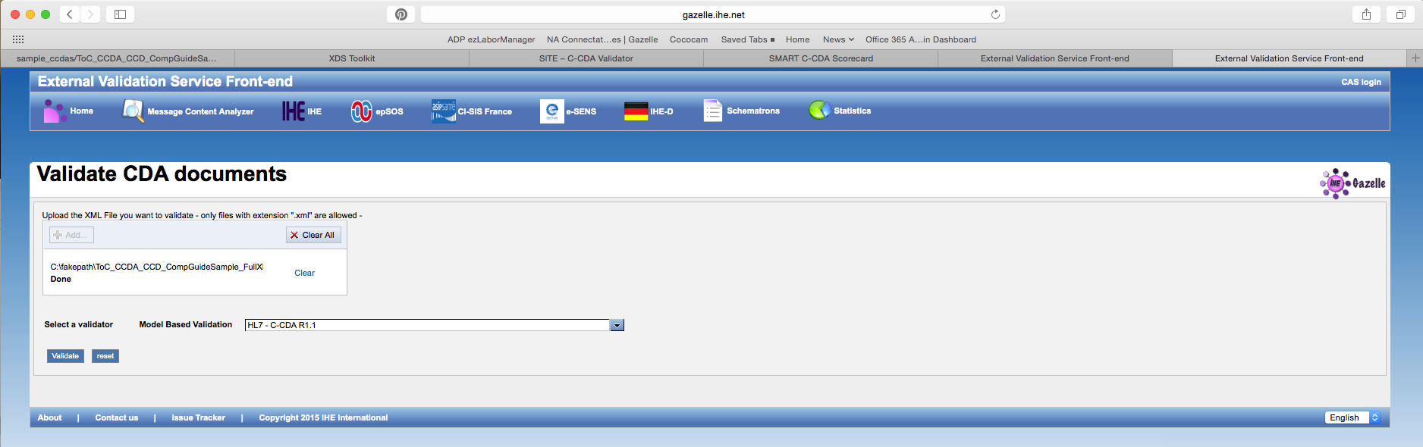
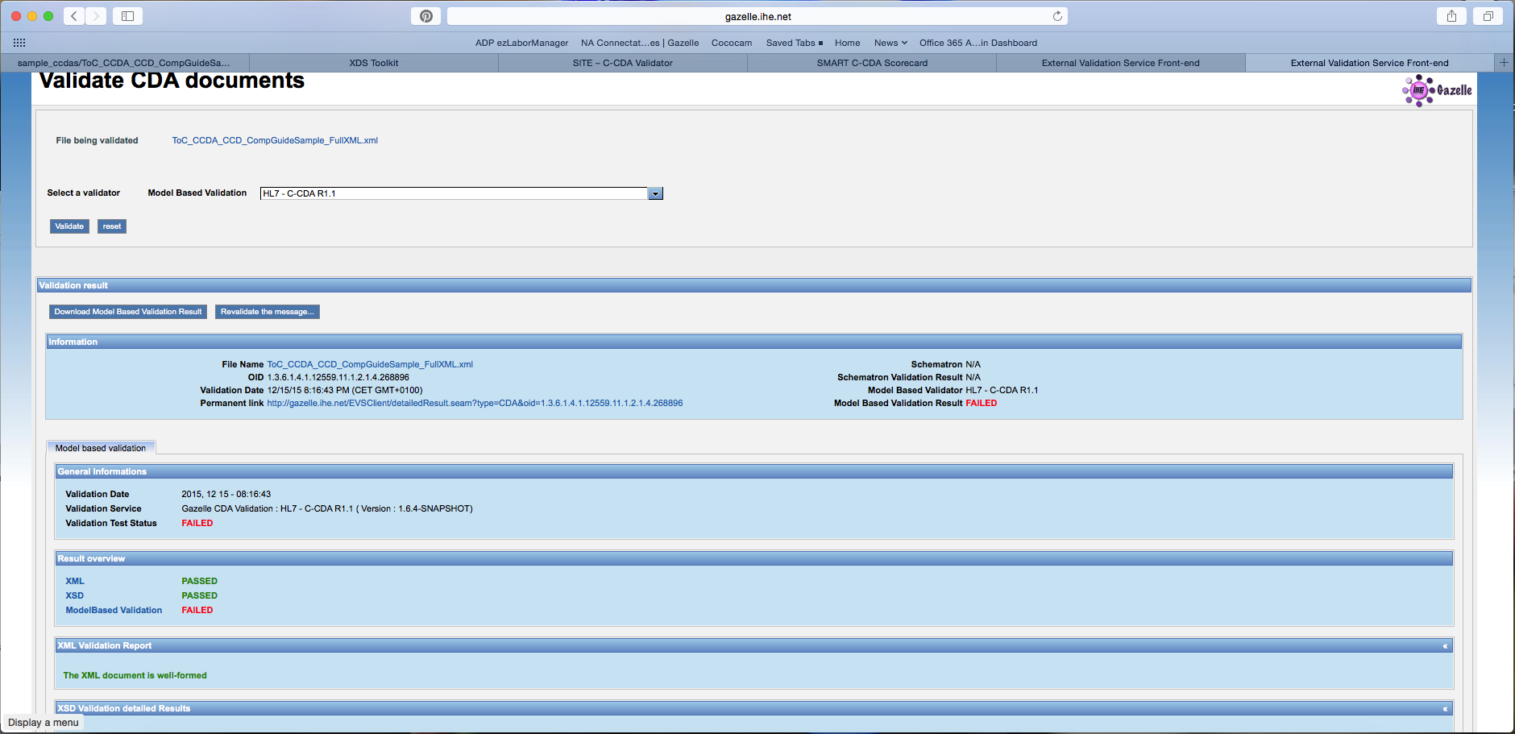

AllNegativeTestingCCDAs.zip

