Step 1: The eHealth Exchange Testing Workgroup (“Testing Workgroup”) will have a roster where workgroup members attendance is tracked for voting rights. If you wish to be added to the voting roster please submit your information here.
In addition, the Testing Workgroup uses a self-managed Google Group mailing list that is searchable and archived. It is monitored to prevent unsolicited or off topic messages. The mailing list is low volume with typically about 1 to 3 messages per week. You can unsubscribe at any time.
We send weekly meeting notices and other low volume announcements via this group. This mailing list is the key mailing list for eHealth Exchange Testing Workgroup discussions.

Step 2: You may add yourself to the Testing Workgroup Google Group.

Subscribe Via Email
To subscribe via email, just use your email account to send a specially-formatted message to the Google Group server. To join this list you can use the web interface or send an email as shown below (to
ehealth-exchange-testing@googlegroups.com
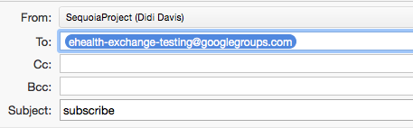
You should then see an email similar to the following. This email MUST be acknowledged in order to actually join the group (you are not a member of the group until you acknowledge this “opt-in” email). To acknowledge it, please click on the “Join This Group” button or link.
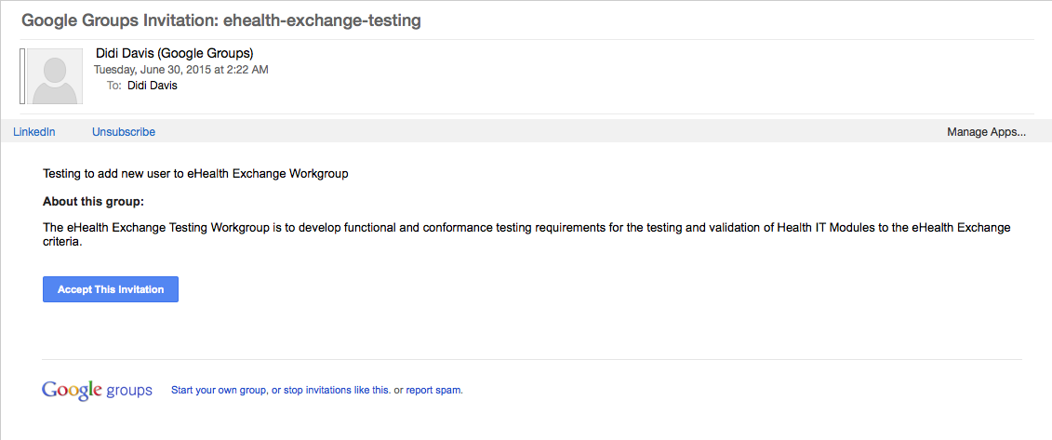

Step 3: Adding yourself to the eHealth Exchange Testing Workgroup Wiki as a Member
You must navigate to the wiki by using this URL and on the top right of screen select Join:
https://ehealth-exchange-testing.wikispaces.com/eHealth+Exchange+Testing+Home

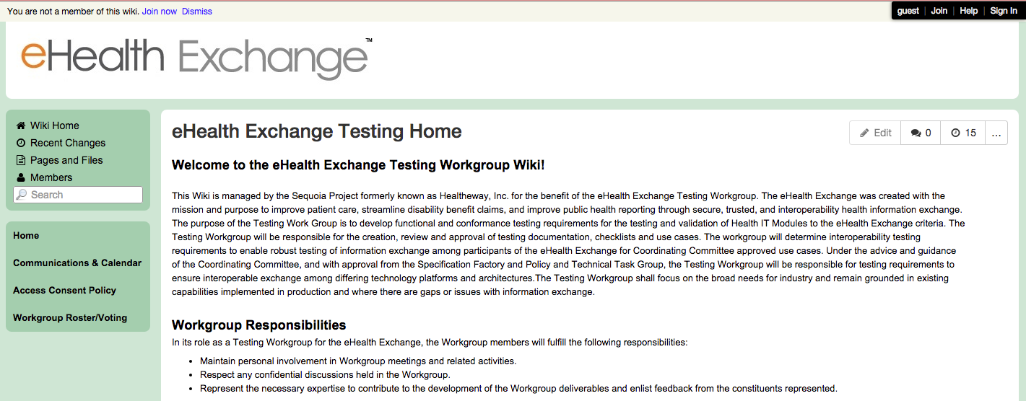
You may create your account on the pop up window provided or sign in. if you already have an account:
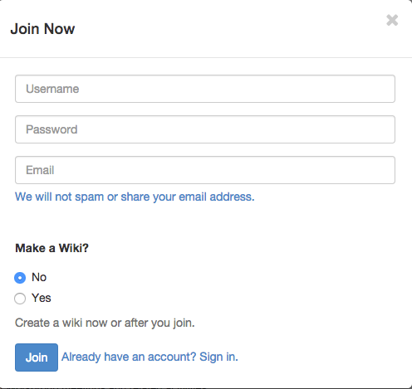

Step 4: Join our Weekly Calls
Instructions for joining each weekly meeting is at the top of this page: https://ehealth-exchange-testing.wikispaces.com/Communications+%26+Calendar
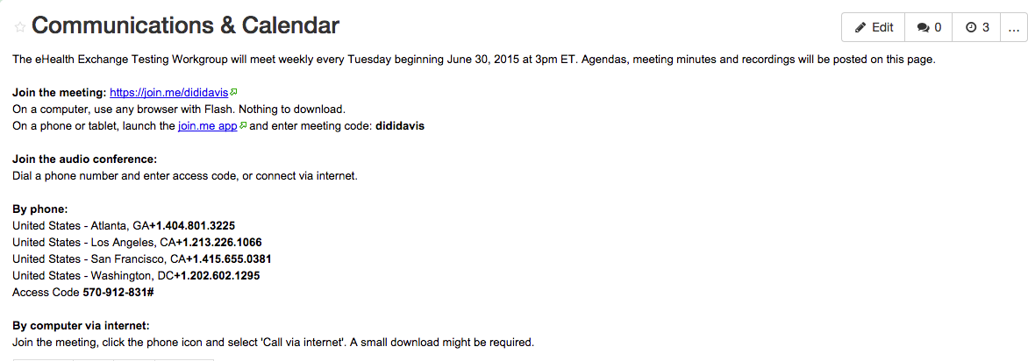
If you have any questions regarding the eHealth Exchange Testing Workgroup, please contact testing@sequoiaproject.org.

