eHealth Exchange
2015 Pilot Access Consent Policy (ACP) Test Cases and Social Security Administration (SSA) Test Cases



Specification Factory/ACP Workgroup
3/12/2015

THIS PAGE INTENTIONALLY LEFT BLANK

Table of Contents
1.1 INTRODUCTION 3
1.2 Business Needs Supported by this testing profile 3
1.3 Sample Scenario Use 3
1.4 Social Security Administration (SSA) Use Case Message Sequencing 5
1.5 END-TO-END TEST SCENARIOS 9
Service Set: SS: SSA Test Cases 9
Scenario: TS: SSA-R-0000.0 9
1.5.1 Test Case: ACP-PD-R-0000.0 9
1.5.2 Test Case: ACP-QD-I-0000.0 11
1.5.3 Test Case: ACP-RD-I-0000.0 14
1.5.4 Test Case: ACP-QD-R-0000.0 16
1.5.5 Test Case: ACP-RD-R-0000.0 19

eHealth Exchange ACP Test Cases – SSA Profile

INTRODUCTION
The eHealth Exchange content specifications define types of content that may be exchanged by nodes across the NHIN to address particular use cases or business needs. Health Information Organizations (HIOs), which act as nodes on the eHealth Exchange are termed NHIOs. These content specifications make use of the NHIO’s discovery and information exchange capabilities and rest upon a foundational set of messaging, security, and privacy services.

This document provides the testing methodology and scenarios required for interoperability testing and exchange of consent policies between eHealth Exchange participants. It references the Access Consent Policy (ACP) specification for the interoperability requirements outlined within. An ACP is an element of an optional SAML statement described in the eHealth Exchange Authorization Framework specification. The purposes of these tests are to:

- Test the content and format of Access Consent policies covering the electronic exchange of health information between NHIOs, and
- To test for the adherence to a standard language for expressing restrictions on access to health information. These restrictions are also known as Access Consent Policies.
- Test for the exchange of Access Consent policies specific to the Social Security Administration (SSA) disability benefits determination implementation.
- Test the use of the “Cross Gateway Query” and “Cross Gateway Retrieve” transactions in support of document exchange

Business Needs Supported by this testing profile
A core requirement of the eHealth Exchange is for consumers “to limit the type of data that may be available to any or selected providers. Although the requirement to restrict access to and disclosure of health information is often described in the context of “consumers” (a term that is more broadly applicable than the term “patient”, and is thus used in this testing program), other types of users may also have the need to restrict access to health information. For example:

1. An NHIO that operates within a state may need to implement restrictions on access to health information as required by that state’s laws.

2. A physician may wish to restrict access to newly created health information by patients until he/she has the opportunity to review the information for accuracy or for any health concerns that he/she wishes to discuss with the patient.

3. These test cases may be used as underlying requirements for various use cases that describe these kinds of restrictions, in addition to those created and adopted by consumers.

Sample Scenario Use
There are likely to be a number of scenarios that will be able to take advantage of this specification. The one described here should be considered as an example as referenced by the NHIN Access Consent Policies Specification v1.0.

A consumer moves to a new city and establishes themselves as a patient with a healthcare provider who participates in an NHIO. As part of establishing their identity within the NHIO, certain Access Consent policies are established as applying to this consumer. Those policies would permit the consumer’s new healthcare provider to retrieve clinical information held by their previous healthcare providers.

When the new healthcare provider attempts to retrieve existing clinical information through the eHealth Exchange using the “Query for Documents” transaction, the NHIO may indicate (Using a mechanism defined in the eHealth Exchange Authorization Framework specification) the Policy ID of an Access Consent policy that the requesting NHIO believes would be germane to the responding NHIO. Using the transactions and Access Consent policy formats defined by the 2010 Access Consent Policy specification, the responding NHIO initiates a Query for Documents and subsequent Retrieve Document transaction to retrieve the Access Consent policy and apply that policy in determining whether to permit the original “Query for Documents” request. See Figure 1: Exchange Access Consent Policies sequence diagram showing the base ACP specification workflow defined below:

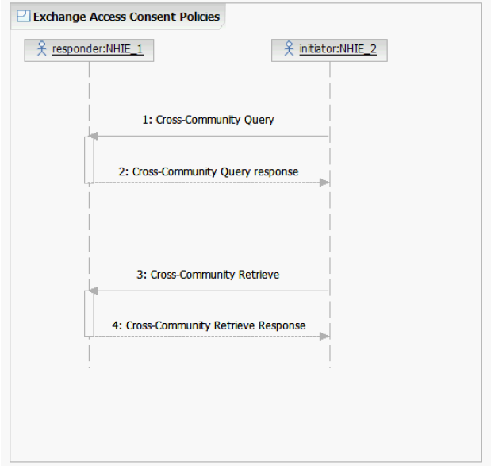
Figure 1: Exchange Access Consent Policies sequence diagram

Conformance to the ACP specification will be validated against the ACP Conformance Checklist (CL_Access_Consent_policy_ACP+SSA.xls).

The Access Consent Policy Testing program will leverage the existing 2010 and 2011 smoke tests to capture the Participant’s Query for Document Response and Retrieve Document Response messages.

Social Security Administration (SSA) Use Case Message Sequencing

    - Section 2.0 of the SSA Interoperability Guide requires Web Services Interfaces
Integration with SSA via the eHealth Exchange is comprised of three web service interfaces:
      - Patient Discovery
      - Query for Documents
      - Retrieve Documents
    - Section 2.2 of the SSA Interoperability Guide requires Query for Documents and Retrieve Documents
      - The Query for Documents and Retrieve Documents interfaces are based on the IHE Cross Community Access (XCA) and the Cross Enterprise Document Sharing (XDS.b) profiles.
      - These interfaces are used to list and retrieve patient-related documents.
      - SSA NHIN gateway = requesting client. Health IT Partner’s gateway = responding gateway.
      - These services will be used to retrieve the patient’s medical information after a patient is discovered at the NHIO.
    - Section 4.1 of the SSA Interoperability Guide requires: Patient Discovery Request
      - Step 1 in the messaging sequence: The Testing Tool sends the Patient Discovery Request message to the Health IT Partner (NHIO).
      - The request will include the following patient’s data:
        - Name (first, middle, last)
        - Gender
        - DOB
        - SSN
        - Address
      - The Testing Tool will be using the Demographic Query only mode of the Patient Discovery transaction (only the demographics of the patient are included in the request). Will not include a patient identifier in the body of the request.
      - Security Assertion Markup Language (SAML) assertion included in the Patient Discovery request from the testing tool will include a Patient Identifier. This identifier is only intended for supporting the privacy policy retrieval and SHALL not be used for creating a patient correlation.
      - The MinimumDegreeMatch element in the request will be set to 100, the highest value defined, to indicate that the responder should have the highest confidence in their patient match response.
    - Section 4.2: Initial Access Control Decision
      - Step 2 in the sequence: The Health IT Partner performs the initial security evaluation.
      - Health IT Partner evaluates the SAML assertion information, source organization, purpose of use, role, and asserted privacy policies and takes a decision whether to act upon the testing tool Patient Discovery request.
      - If the Health IT Partner does not accept the SAML assertion statements, it SHOULD return an HTTP Error 403 Forbidden error code and include a reason for the refusal.
    - Section 4.3: Query for Documents Request (For Access Consent Policy)
      - Step 3 in the messaging sequence: Health IT Partner sends a Query for Documents Request message to the testing tool.
      - Health IT Partner SHALL set the value of the patient identifier in the request message to the Patient Identifier value that was included in the SAML assertion of the Patient Discovery request from the testing tool.
      - $XDSDocumentEntryPatientID SHALL be populated with the Patient Identifier value that was included in the SAML assertion of the Patient Discovery request from SSA.
      - $XDSDocumentEntryStatus SHALL be populated with ‘urn:oasis:names:tc:ebxml-regrep:StatusType:Approved’
      - $XDSDocumentEntryClassCode MAY be populated with LOINC code of 57016-8 (privacy policy acknowledgement).
      - $XDSDocumentEntryEventCodeList SHALL be populated with the InstanceAccessPolicy value included in the SAML assertion authorization decision statement of the Patient Discovery request from SSA.
    - Section 4.4: Query for Documents Response (For Access Consent Policy)
      - Step 4: The testing tool sends a Query for Documents Response message to the Health IT Partner.
      - The Query for Documents Response will contain the list of access consent policies that can be retrieved for the patient.
      - The following table contains a sample of the XDS metadata values that the Health IT Partner can expect to receive from the testing tool:
XDS Metadata | Value
availabilityStatus | urn:oasis:names:tc:ebxml-regrep:StatusType:Approved
classCode | 57016-8 (LOINC)
classCode DisplayName | Privacy Policy Acknowledgement
confidentialityCode | N (Normal)
formatCode | urn:ihe:iti:bppc-sd:2007
formatCode codeSystem | 1.3.6.1.4.1.19376.1.2.3
healthcareFacilityTypeCode | 385432009 (SNOMED CT code for Not Applicable)
mimeType | text/xml
practiceSettingCode | 385432009 (SNOMED CT code for Not Applicable)
serviceStartTime | Effective start date of privacy policy (authorization)
serviceStopTime | Effective end date of privacy policy (authorization)
Title | AUTHORIZATION TO DISCLOSE INFORMATION TO THE SOCIAL SECURITY ADMINISTRATION

    - Section 4.5: Retrieve Document Request (For Access Consent Policy)
      - Step 5: Health IT Partner sends a Retrieve Document Request message to the testing tool to retrieve access consent policy documents.
      - Once the testing tool has received the last Retrieve Document response message, the ability to retrieve the access consent policy will no longer be allowed.
    - Section 4.6: Retrieve Document Response (For Access Consent Policy)
      - Step 6: The testing tool sends Retrieve Document Response message to the Health IT Partner.
      - The testing tool will respond with the access consent policy document (Authorization to Release Information) identified in the Retrieve Document request message.
    - Section 4.7: Final Access Control Decision
      - Step 7: Health IT Partner makes the final access control decision.
      - Health IT Partner reviews the access consent policy obtained in the previous step and makes a decision regarding whether they will accept the policy and allow for the release of medical information.
      - The Health IT Partner SHOULD use the access consent policy identifier as a reference mechanism when establishing the permissions for the response to the testing tool.
    - Section 4.8: Patient Discovery Response
      - Step 8: Health IT Partner sends a Patient Discovery Response message to the testing tool.
      - If the patient discovery query returns no matches, the Health IT Partner should return an empty result set per the specification.
        - Patient not found: When an NHIN participant’s gateway is unable to locate the patient based on demographics data provided in the PD request by the testing tool.
      - If the patient discovery request results in an ambiguous match, the Health IT Partner should return an empty result set. When ambiguous matches are close, the Health IT partner may use a response code of ‘AnswerNotAvailable’
        - Ambiguous Match: When an NHIN participant’s gateway has located more than one patient.
      - If the patient query results in an unambiguous match for the Health IT partner, the Health IT partner identifier for the patient and the patient demographics that the Health IT Partner matched on SHOULD be returned.
    - Section 4.9: Query for Documents Request (For Clinical Document)
      - Step 9: The testing tool sends a Query for Documents request message to the HIT Partner.
      - The Health IT Partner SHALL support queries based on the following parameters (slots):
$XDSDocumentEntryFormatCode
$XDSDocumentEntryPatientId
$XDSDocumentEntryServiceStartTimeFrom
$XDSDocumentEntryServiceStartTimeTo
$XDSDocumentEntryServiceStopTimeFrom
$XDSDocumentEntryServiceStopTimeTo
$XDSDocumentEntryStatus
      - For Health IT Partners that support dynamic creation of documents, the partner SHALL explicitly look for queries where the $XDSDocumentEntryStatus is set to a value of ‘urn:ihe:iti:2010:StatusCode:DeferredCreation’. In this situation, the document data SHALL honor the service start and stop time values, if they are specified in the request. (Please note prior discussion thread by the eHealth Exchange Specification factory with additional information on this topic can be found at (http://exchange-specifications.wikispaces.com/share/view/54214588)
      - For Health IT Partners that support a repository of static documents, the partner SHALL explicitly look for queries where the $XDSDocumentEntryStatus is set to a value of ‘urn:oasis:names:tc:ebxml-regrep:StatusType:Approved’ ‘In this situation, the list of available documents SHALL honor the service start and stop time values, if they are specified in the request.
      - Empty strings in a query SHALL be treated as being equal to NULL or empty value, which is not the same as an unspecified value.
    - Section 4.10: Query for Documents Response (For Clinical Document)
      - Step 10: Health IT Partner sends the Query for Documents response message to the testing tool.
      - Response message contains the list of electronic medical record documents that the testing tool can retrieve.
    - Section 4.11: Retrieve Documents Request (For Clinical Document)
      - Step 11: The testing tool sends Retrieve Document request message to Health IT Partner for each of the document references that were returned to SSA in the Query for Documents response message.
    - Retrieve Documents Response (For Clinical Document)
      - Step 12: Health IT Partner sends Retrieve Document response message to the testing tool.
      - Response message contains the requested document.

This section describes the sequencing of the Patient Discovery, Query for Documents, and Retrieve Document messages that comprise the integration with SSA. The following diagram depicts the message sequence.

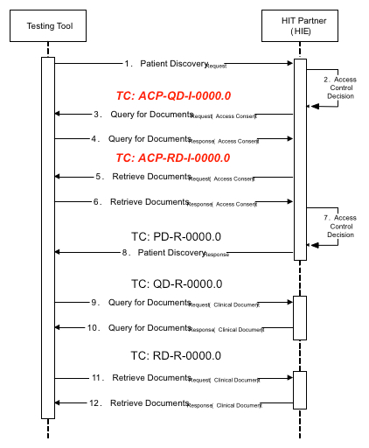
Figure 2: eHealth Exchange (eHEX) Messaging between the testing tool and System Under Test (SUT)

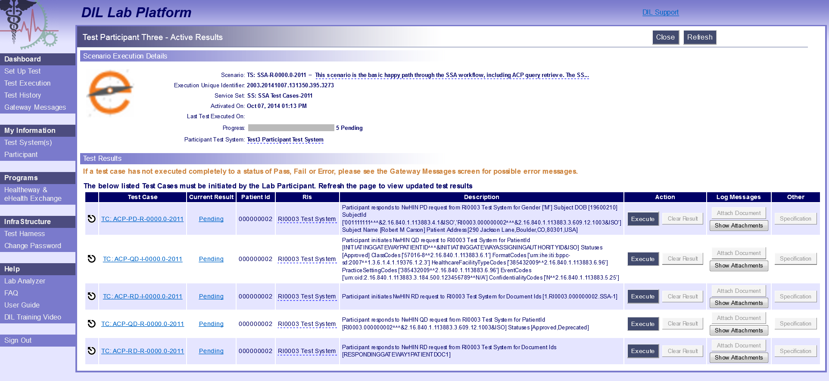
Figure 3: DIL Screenshot – Service Set: SS: SSA Test Cases

END-TO-END TEST SCENARIOS
The following test cases are part and parcel of the Service Set and Test Scenario outlined below. There will be 2010 and 2011 versions of the Service Sets.

Service Set: SS: SSA Test Cases

Scenario: TS: SSA-R-0000.0

Test Case: ACP-PD-R-0000.0
eHealth Exchange ACP Testing
TEST CASE
Development Requirement Specification

Test Case ID | TC: ACP-PD-R-0000.0
Title | Respond to a basic PD for patient found / Patient discovery request
Release Date
Version
SUT Role: | Responder

Coverage Specifications
2011 Exchange | True
2010 Exchange | True
IHE Profile | XCPD
Flow | Basic Success
Optionality | Required

Purpose/Description
Testing Tool sends a PD Request to the System with the required elements. System responds with a match.

Preconditions
Data Load Set
Data Notes | P-000000002

Test Steps
The Testing Tool sends an immediate PD Request to the System with the following parameters, with values taken from patient P-000000002:

SOAP Header = MP: MA Default Request (SUT) Message Parameters
LivingSubject Name
LivingSubjectAdministrativeGender
LivingSubjectBirthTime
LivingSubjectID- SSN
PatientAddress (Address#1)
Subject Role (i.e. Social Worker)
  - Type = CE
  - Code = 106328005
  - Code System = 2.16.840.1.113883.6.96
  - Code System Name = SNOMED_CT
  - Display Name = Social worker
Purpose of Use (i.e. Coverage)
  - Type = CE
  - Code = COVERAGE
  - Code System = 2.16.840.1.113883.3.18.7.1
  - Code System Name = nhin-purpose
  - Display Name = Disclosures for insurance or disability coverage determination
Patient Identifier (Resource ID) = [P-000000002 Resource ID]
Authorization Decision Statement.InstanceAccessConsentPolicy = urn:oid: 2.16.840.1.113883.3.184.50.1

Expected Results
The System returns a PD Response with a match for patient P-0000000002.

Note that the Patient Discovery response will not be sent to the Testing Tool until the ACP Query and Retrieve test scenarios (outlined below) have completed successfully.

Verify conformance of the PD Request to the:
- CL: PD Responder Response Checklist
- CL: MA SOAP Response Checklist
- CL: ACP
- CL: SSA

Referenced Specifications

2011 Exchange Specification
  Patient Discovery v2.0
2011 Underlying Specification
  IHE IT Infrastructure Cross-Community Patient Discovery (XCPD) ITI-55 (Version 2010-08-10) and
  IHE IT Infrastructure Technical Framework Vol.1 & 2a, 2x, 3 (Revision 7.0 2010-08-10)
2010 Exchange Specification
  Patient Discovery v1.0
2010 Underlying Specification
  IHE IT Infrastructure Cross-Community Patient Discovery (XCPD) ITI-55 – (Version 2009-08-10) and
  IHE IT Infrastructure Technical Framework Vol.1 & 2a, 2x, 3 (Revision 6.0 2009-08-10)

Test Case: ACP-QD-I-0000.0
eHealth Exchange ACP Testing
TEST CASE
Development Requirement Specification

Test Case ID | TC: ACP-QD-I-0000.0
Title | Send a basic ACP QD
Release Date
Version
SUT Role: | Initiator

Coverage Specifications
2011 Exchange | True
2010 Exchange | True
IHE Profile | XCA
Flow | Basic Success
Optionality | Required

Purpose/Description
System initiates ACP QD synchronous Find Documents request to the Testing tool with the required parameters. Testing tool responds with the matching policy document(s) metadata.

Preconditions
Data Load Set
Data Notes | P-000000002

Test Steps
The System sends a synchronous/immediate ACP Find Documents Request to the Testing Tool, using the following required parameters:

SOAP Header = MP: MA Default Request (SUT) Message Parameters
$XDSDocumentEntryPatientID = [P-000000002 Resource ID]
$XDSDocumentEntryStatus = Approved
$XDSDocumentEntryClassCode = LOINC code of 57016-8 with scheme "2.16.840.1.113883.6.1”
$XDSDocumentEntryEventCodeList = [Instance Access Policy OID from PD Request with scheme “N/A”]
returnType = LeafClass
SOAP request = synchronous
returnComposedObjects = true

SSA confirmed ACP documents are always Stable. We will allow a participant to request something other than Stable.

For 2010 and 2011 the System Under Test can request Approved only or Approved + DeferredCreation

For 2011 the System Under Test can request Stable only or Stable + On Demand

Expected Results
The Testing Tool successfully processes the Request and returns a Response to the System that contains the following objects:

A ‘Document Match’ for [D-000000002.SSA-1]
Note: The parameters that are part of the Request should be the minimum that’s checked on the Response.

Verify conformance of the QD Request to the:
- CL: QD Initiator Request Checklist
- CL: QD Initiator FindDocuments Checklist
- CL: MA SOAP Request Checklist
- CL: ACP
- CL: SSA

Referenced Specification

2011 Exchange Specification
  Query for Documents v3.0
2011 Underlying Specification
  IHE IT Infrastructure Technical Framework Supplement XCA (Version 2010-08-10)
  IHE IT Infrastructure Technical Framework Vol. 1 & 2a, 2b, 2x, 3 (Revision 7.0 – 2010-08-10)
2010 Exchange Specification
  Query for Documents v2.0
2010 Underlying Specification
  IHE IT Infrastructure Technical Framework Supplement XCA (Version 2009-8-10)
  IHE IT Infrastructure Technical Framework Vol. 1 & 2a, 2b, 2x, 3 (Revision 6.0 – 2009-08-10)

Test Case: ACP-RD-I-0000.0
eHealth Exchange ACP Testing
TEST CASE
Development Requirement Specification

Test Case ID | TC: ACP-RD-I-0000.0
Title | Send a basic ACP RD (retrieve document request)
Release Date
Version
SUT Role: | Initiator

Coverage Specifications
2011 Exchange | True
2010 Exchange | True
IHE Profile | XCA
Flow
Optionality | Required

Purpose/Description
System initiates a synchronous ACP Retrieve Documents request for one document to the Testing Tool. Testing tool responds with the requested policy document.

Preconditions
Data Load Set
Data Notes | P-000000002

Test Steps
The System transmits to the Testing Tool a synchronous Retrieve Documents request for one policy document using the following required parameters:

SOAP Header = MP: MA Default Request (SUT) Message Parameters
RepositoryUniqueId: [Repository ID for D-000000002.XSSA-1]
DocumentUniqueId: [Document ID for D-000000002.XSSA-1]
homeCommunityId: [HCID for the Testing Tool]

Expected Results
The Testing Tool returns to the System an RD Response containing
the requested document:

RegistryResponse/@status:Success
DocumentResponse: 1 present, contains document D-000000002.SSA-1.

Verify conformance of the RD Request to the:
- CL: RD Initiator Request Checklist
- CL: MA SOAP Request Checklist

Referenced Specifications

2011 Exchange Specification
  Retrieve Documents v3.0
2011 Underlying Specification
  IHE IT Infrastructure Technical Framework Supplement XCA (Version 2010-08-10)
  IHE IT Infrastructure Technical Framework Vol. 1 & 2a, 2b, 2x, 3 (Revision 7.0 – 2010-08-10)
2010 Exchange Specification
  Retrieve Documents v2.0
2010 Underlying Specification
  IHE IT Infrastructure Technical Framework Supplement XCA (Version 2009-8-10)
  IHE IT Infrastructure Technical Framework Vol. 1 & 2a, 2b, 2x, 3 (Revision 6.0 – 2009-08-10)

Test Case: ACP-QD-R-0000.0
eHealth Exchange ACP Testing
TEST CASE
Development Requirement Specification

Test Case ID | TC: ACP-QD-R-0000.0
Title | Respond to a basic QD (query for documents response)
Release Date
Version
SUT Role: | Responder

Coverage Specifications
2011 Exchange | True
2010 Exchange | True
IHE Profile | XCA
Flow | Basic Success
Optionality | Required

Purpose/Description
Testing Tool initiates QD synchronous Find Documents request to the System with the required parameters. System responds with the matching policy document(s) metadata.

Preconditions
Data Load Set
Data Notes | P-0000000002

Test Steps
The Testing Tool sends a synchronous Find Documents Request to the System, using the following required parameters:

SOAP Header = MP: MA Default Request (SUT) Message Parameters
$XDSDocumentEntryPatientID = [P-0000000002 PID]
$XDSDocumentEntryStatus = Approved or Deprecated OR DeferredCreation NOTE: Only send DeferredCreation for 2010
$XDSDocumentEntryType = [Stable OR On-Demand Documents] NOTE” Only send $XDSDocumentEntryType parameter for 2011
returnType = LeafClass
SOAP request = synchronous
returnComposedObjects = true
Authorization Decision Statement.InstanceAccessConsentPolicy = urn:oid: 2.16.840.1.113883.3.184.50.1

Expected Results
The System successfully processes the Request and returns a Response to the Testing Tool that contains the following objects:

2011 ONLY:
One Stable document entry with:
-A 'DocumentMatch' of: XDSDocumentEntry.uniqueId = D-00000002.1 OR (XDSDocumentEntry.patientID = [P-00000002 PID] AND XDSDocumentEntry.authorPerson = [value from D-00000002.1])
-A match on: XDSDocumentEntry.status = [value from D-00000002.1]
-A match on: XDSDocument.objectType = [value from D-00000002.1]

If the SUT is testing as an On-Demand system, they would send one On-Demand document entry with:
-A 'DocumentMatch' of either: XDSDocumentEntry.uniqueId = D-00000002.1 OR (XDSDocumentEntry.patientID = [P-00000002 PID] AND XDSDocumentEntry.authorPerson = [value from D-00000002])
-A match on: XDSDocumentEntry.status = [value from D-00000002.1]
-A match on: XDSDocument.objectType = [value from D-00000002.1]

NOTE: The creationTime, hash, and size SHALL not be included in the Response for an On-Demand system. The legalAuthenticator SHOULD not be included in the Response.

2010 ONLY:

If the SUT serves only static (i.e. not DeferredCreation) documents,, they would send one Static document with:
-A 'DocumentMatch' of either: XDSDocumentEntry.uniqueId = D-00000002.1 OR (XDSDocumentEntry.patientID = [P-00000002 PID] AND XDSDocumentEntry.authorPerson = [value from D-00000002.1])
-A match on: XDSDocumentEntry.status = [value from D-00000002.1]
-A match on: XDSDocument.objectType = [value from D-00000002.1]

In addition to, if the SUT is testing as a DeferredCreation system, they would send one DeferredCreation document with:
-A 'DocumentMatch' of either: XDSDocumentEntry.uniqueId = D-00000002.1 OR (XDSDocumentEntry.patientID = [P-00000002 PID] AND XDSDocumentEntry.authorPerson = [value from D-00000002.1])

Verify conformance of the QD Response to the:
- CL: QD Responder Response Checklist
- CL: MA SOAP Response Checklist
- CL: ACP
- CL: SSA

Referenced Specifications

2011 Exchange Specification
  Query for Documents v3.0
2011 Underlying Specification
  IHE IT Infrastructure Technical Framework Supplement XCA (Version 2010-08-10)
  IHE IT Infrastructure Technical Framework Vol. 1 & 2a, 2b, 2x, 3 (Revision 7.0 – 2010-08-10)
2010 Exchange Specification
  Query for Documents v2.0
2010 Underlying Specification
  IHE IT Infrastructure Technical Framework Supplement XCA (Version 2009-8-10)
  IHE IT Infrastructure Technical Framework Vol. 1 & 2a, 2b, 2x, 3 (Revision 6.0 – 2009-08-10)

Test Case: ACP-RD-R-0000.0
eHealth Exchange ACP Testing
TEST CASE
Development Requirement Specification

Test Case ID | TC: ACP-RD-R-0000.0
Title | Respond to a basic RD (retrieve document response)
Release Date
Version
SUT Role: | Responder

Coverage Specifications
2011 Exchange | True
2010 Exchange | True
IHE Profile | XCA
Flow
Optionality | Required

Purpose/Description
Testing Tool initiates a synchronous Retrieve Documents request for one document to the System. System responds with the requested document.

Preconditions
Data Load Set
Data Notes | P-000000002

Test Steps
The Testing Tool transmits to the System a synchronous Retrieve Documents request for one document using the following required parameters:

2011 ONLY:
SOAP Header = MP: MA Default Request (TestTool) Message Parameters
RepositoryUniqueId: [Repository ID for D-000000002.1]
DocumentUniqueId: [Document ID for D-000000002.1]
homeCommunityId: [HCID for the System]
Authorization Decision Statement.InstanceAccessConsentPolicy = urn:oid: 2.16.840.1.113883.3.184.50.1

If the SUT is testing as an On-Demand system, the following On-Demand document
would also need to be retrieved:
SOAP Header = MP: MA Default Request (TestTool) Message Parameters
RepositoryUniqueId: [Repository ID for the System]
RepositoryUniqueId: [Repository ID for D-000000002.1]
DocumentUniqueId: [Document ID for D-000000002.1]
homeCommunityId: [HCID for the System]

2010 ONLY:
If the SUT is testing as a Stable system, the following Stable document would need to be retrieved:
SOAP Header = MP: MA Default Request (TestTool) Message Parameters
RepositoryUniqueId: [Repository ID for D-000000002.1]
DocumentUniqueId: [Document ID for D-000000002.1]
homeCommunityId: [HCID for the System]

Otherwise, if the SUT is testing as a DeferredCreation system, the following
DeferredCreation document would need to be retrieved:
SOAP Header = MP: MA Default Request (TestTool) Message Parameters
RepositoryUniqueId: [Repository ID for the System]
RepositoryUniqueId: [Repository ID for D-000000002.1]
DocumentUniqueId: [Document ID for D-000000002.1]
homeCommunityId: [HCID for the System]

Expected Results
The System returns to the Testing Tool an RD Response containing the requested document:

2011 ONLY:
RegistryResponse/@status:Success
DocumentResponse: 1 present, contains document [D-000000002.1]
RepositoryUniqueId: [Repository ID for [D-000000002.1]
DocumentUniqueId: [Document ID for [D-000000002.1]
homeCommunityId: [HCID for the System]

If the SUT is testing as an On-Demand system, the following On-Demand document
would be in the Response:
RepositoryUniqueId: [Repository ID for [D-000000002.1]
DocumentUniqueId: [Document ID for [D-000000002.1]
homeCommunityId: [HCID for the System]
- Attribute NewRepositoryUniqueId should be present
- Attribute NewDocumentUniqueId should be present

2010 ONLY:
If the SUT is testing as a Stable system, the following Stable document would be in
the Response:
RegistryResponse/@status:Success
DocumentResponse: 1 present, contains document [D-000000002.1]
RepositoryUniqueId: [Repository ID for [D-000000002.1]
DocumentUniqueId: [Document ID for [D-000000002.1]
homeCommunityId: [HCID for the System]
- Attribute NewRepositoryUniqueId should be present
- Attribute NewDocumentUniqueId should be present

If the SUT is testing as a DeferredCreation system, the following DeferredCreation document would be in the Response:
RepositoryUniqueId: [Repository ID for [D-000000002.1]
DocumentUniqueId: [Document ID for [D-000000002.1]
homeCommunityId: [HCID for the System]
- Attribute NewRepositoryUniqueId should be present
- Attribute NewDocumentUniqueId should be present

Verify conformance of the PD Request to the:
- CL: RD Responder Request Checklist
- CL: MA SOAP Response Checklist

Referenced Specifications
2011 Exchange Specification
  Retrieve Documents v3.0
2011 Underlying Specification
  IHE IT Infrastructure Technical Framework Supplement XCA (Version 2010-08-10)
  IHE IT Infrastructure Technical Framework Vol. 1 & 2a, 2b, 2x, 3 (Revision 7.0 – 2010-08-10)
2010 Exchange Specification
  Retrieve Documents v2.0
2010 Underlying Specification
  IHE IT Infrastructure Technical Framework Supplement XCA (Version 2009-8-10)
  IHE IT Infrastructure Technical Framework Vol. 1 & 2a, 2b, 2x, 3 (Revision 6.0 – 2009-08-10)

